ГОДИШНИК НА МИННО-ГЕОЛОЖКИЯ УНИВЕРСИТЕТ “СВ. ИВАН РИЛСКИ”, Том 58, Св. I, Геология и геофизика, 2015
ANNUAL OF THE UNIVERSITY OF MINING AND GEOLOGY “ST. IVAN RILSKI”, Vol. 58, Part I, Geology and Geophysics, 2015

GEOCHEMICAL COMPOSITION AND PROPERTIES OF ANTARCTIC SOIL SAMPLES FROM LIVINGSTON ISLAND

Irena Kostova¹, Denitsa Apostolova¹, Ekaterina Filcheva², Laslo Klain¹, Mitko Popov³

¹ Sofia University “St. Kl. Ohridski”, Department of Geology, 1000 Sofia
² Institutе of Soil Science, Agrotechnologies and Plant Protection “N. Poshkarov”, 1080; Sofia,
³ Geological Institute, Bulgarian Academy of Sciences, 1113 Sofia,

ABSTRACT. Soil samples situated near to Bulgarian Antarctic Base in Livingstone Island have been studied morphologically, mineralogically and geochemically in order to understand soil formation processes and to determine major, minor and trace elements content. The analysis of organic matter, chemical analysis, optical microscopy, XRD and LA-ICP-MS were applied. The obtained data show that the processes of the humus formation, respectively soil formation are rather primitive and in very initial stage of formation. The sources of soil organic matter are scarce vegetation (lichens, mosses and rarely grass) remains and bird and penguin excrements, which play an important role on the humus formation processes. The low degree of humification is also due to the presence of very unfavourable climatic conditions. Morphological study shows that the soils are very slightly to slightly transformed and the processes of decay are uncompleted. The minerals identified in soils are quartz, plagioclase, K-feldspar, kaolinite and magnetite. Close connection between the mineral composition of soils and sedimentary rocks, which forms the rock basement was proved. The inorganic matter of soils was produced mainly by physical weathering of the sediments. The most elements in soils are generally around or below the Clark values for the sediments, with the exception of Sc, V, Co, Cu, Zn, Ga, Sr, Cd and partly of As and Pb which exceed two, three or more times the average concentration for sedimentary rocks. The total concentrations of heavy metals and other toxic elements, although some increased amount of Cd, Zn, Pb, Sr and As do not show any definite evidence of local or global anthropogenic contamination.

Keywords: Antarctic soils, geochemistry, mineralogy, humic acids, fulvicacids.

ГЕОХИМИЧЕН СЪСТАВ И СВОЙСТВА НА ПОЧВИ ОТ ОСТРОВ ЛИВИНГСТЪН, АНТАРКТИДА
Ирена Костова¹, Деница Апостолова¹, Екатерина Филчева², Ласло Клайн¹, Митко Попов³
¹ Софийски университет „Св. Кл. Охридски”, 1000 София
² Институт по почвознание агротехника и растителна защита „Н. Пушкаров”, 1080 София
³ Геологически институт, БАН, 1113 София

РЕЗЮМЕ. Почви от околностите на Българската Антарктическа База на о. Ливингстън са изследвани от морфоложка, минераложка и геохимична гледна точка, за да се изясни процесът на образуването им и да се определи съдържанието на основни, второстепенни и елементи-примеси в тях. Извършени са анализ на органичното вещество, химичен анализ, оптична микроскопия, XRD и LA-ICP-MS. Получените резултати показват, че процесите на образуване на хумус (почвообразуването) са доста примитивни и се намират в съвсем начален етап. Източник на органичното вещество в почвата са останки от оскъдната растителност (лишеи, мъхове и рядко трева) и екскрементите на птици и пингвини, които играят важна роля в процеса на образуване на хумуса. Ниската степен на хумификация се дължи и на изключително неблагоприятните климатични условия. Морфоложките изследвания показват слаба трансформация на почвеното вещество и незавършен етап на разлагане на компонентите. В почвите са установени кварц, плагиоклаз, К фелдшпат, каолинит и магнетит. Съществува тясна връзка между минералния състав на почвите и скалите, които формират скалната основа на терена. Неорганичното вещество на почвите е формирано главно в резултат на физичното изветряне на седиментната покривка. Съдържанието на повечето елементи е около или по-ниско от средно статистическата стойност за съдържанието на същия елемент в седиментни скали. Изключение правят Sc, V, Co, Cu, Zn, Ga, Sr, Cd и отчасти As и Pb, които имат стойности два, три и повече пъти по-високи в изследваните почви от средното им съдържание в седиментните скали. Съдържанието на тежки метали и други токсични елементи, въпреки повишеното съдържание на някои от тях (Cd, Zn, Pb, Sr и As) в почвите, не дава основание да се смята, че съществува локално или глобално антропогенно замърсяване.

Ключови думи: Антарктически почви, геохимия, минералогия, хуминови киселини, фулвокиселини

Introduction

The Bulgarian Antarctic Base “St. Kliment Ohridski” is situated at the eastern coast of the South Bay of the Livingston Island, the second largest among the South Shetland Archipelago. Bulgarian Antarctic scientific research in this region started in 1993 with different programmes: geological, life sciences, glaciology etc.

During the last years the scientists pay a great attention to human impacts on the Antarctic environment. Since the soils are a major recipient of human disturbances, there have been a number of studies focusing on various aspects of soil disturbances (Ugolini and Bockheim, 2008). Claridge et al. (1995) and Sheppard et al. (1994) are the first, who reported data about metal contamination in soils at Marble Point and around Vanda Station, 40 years after human occupation. Later, other authors also conducted a numerous investigations and estimate the level of concentrations of metals and other toxic elements including As, Cd, Se, Sr and rare earth elements (REE) in the soils sampled from Scott Base and King George Island situated in different Antarctic areas (Sheppard et al., 2000; Lee et al., 2004).

Assessment of the anthropogenic contaminations of soils from King George Island using geochemical markers has been published by Prus et al. (2015). Geochemical characterization of Antarctic soils and lacustrine sediments from Terra Nova Bay and the possible influence of human activity and/or global contamination have been discussed by Malandrino et al. (2009). Claridge et al. (1999) conduct an experiment using lithium chloride as a tracer to answer the question of a possibility of contaminant movement in Antarctic soils. Physical aspects of soil disturbances and means of undertaking assessments were investigated by Campbell et al. (1998). The damage effects of fuel spills on soils and the capacity for remediation by soil organism have been studied by Aislabie et al. (2001) and Balks et al. (2002).

There are two more detailed investigations described the composition, properties and some ecological aspects concerning soils sampling around BAB at Livingstone Island and published by Sokolovska et al. (1996, 2015). In order to better understanding of geochemical and environmental processes which take place in Antarctic soils and other ecosystems two soil samples (respectively North and South of the BAB) were collected from Hurd Peninsula of Livingston Island during the Bulgarian Expedition carried out in 2014-2015. It is the first step of a large scale project for investigation and monitoring of the geochemical composition of Antarctic soils and related sediments around BAB on the Livingston Island and evaluation of its eventual anthropogenic contaminations with heavy metal and other toxic trace elements, which should be conducted during the next few years.

The goal of the present investigation is to specify some main characteristics of soil samples, to define the organic matter (total organic carbon, humic and fulvic acids, humic acid fractions et al.) to describe their mineral composition, to determine the major, minor and trace elements concentrations and to make some speculations regarding the influence of human activities and/or global contamination on the studied soils.

Geological setting

Livingston Island is the second largest of the South Shetland Islands with territory of about 800 km². The Bulgarian Antarctic Base is situated at the Hurd Peninsula. Hurd Peninsula is located in the central part of Livingston Island and is covered by a thick snow-ice cap called Hurd Glacier. Free of ice territory in the vicinity of the Bulgarian Antarctic Base (BAB) differs from 3 to 5 km².

The sedimentary sequences exposed on the peninsula are presented of the rocks of Miers Bluff Formation. The volcanic rocks are intruded by different in composition and age dykes. From a structural point of view, the sedimentary section represents an overturned limb of a large scale monocline (Bonev et al., 2015).

The geological map of the Hurd Peninsula and sedimentary sequence section are given in Figure 1. Two types of rocks – sedimentary and volcanic are expose at that area. They refer to two major lithostratigraphic units, namely the Miers Bluff Formation, which includes sedimentary rocks and Mount Bowles Formation, which includes volcanic rocks. The Miers Bluff Formation is widely exposed on the west, central and northern parts of the Hurd Penisula where the Bulgarian Antarctic Base (BAB) and sampled area are situated. The formation is characterized by siliciclastic (turbidite) sedimentary sequences (Smellie et al., 1995). The sediments of Miers Bluff Formation are slightly altered, underwent a low grade of metamorphic changes and commonly crossed by dykes, which form additional contact alterations (Pimpirev et al., 2015). Lithologically the Miers Bluff Formation includes various siliciclastic sedimentary rocks: sendstones are dominant (in the lower part), turbidites, presented by alternation of sandstones, siltstones and mudstones (in the middle part), and conglomerates, breccias and breccias-conglomerates (in the upper part) (Fig. 1). The sediments of the formation are strongly compacted, randomly tectonized and slightly altered (Pimpirev et al., 2015). The thickness of the formation exceeds 2600 m. The Miers Bluff Formation consists of five units (South Bay Member, Johnsons Dock Member, Sally Rocks Members, Napier Peak Member and Moores Peak Member) and the sediments from the first one, South Bay Member is reveals in the sampled area.

The sedimentary sequence of the South Bay Member is given on Figure 1. According to Pimpirev et al. (2015) it consists of medium and coarse-grained massive sandstones alternating with thick mudstones and fine-grained sandstones packets. Breccia-conglomerates layers are rarely presented. Plant debris and traces of erosional textures are also observed. The sediments of this member have been deposited in a deltaic setting (Pimpirev et al., 2012). Based on biostratigraphic data and especially the recorded nannofossil associations in the sediments Stoykova et al. (2002) and Pimpirev et al. (2006) determine the geological age of the Miers Bluff Formation as Late Cretaceous, Campanian-Maastrichtian.

Environmental settings and sampling
On a global scale the terrestrial environments of the Antarctic areas are rather dynamic and variable and can be characterized with extremely low temperatures, low moisture availability, frequent changing freeze and thaw cycles, scarce vegetation cover, and limited amount of organic matter (Convey, 1996). Only 10% of the territory of Livingston Island from the total about 800 km² is ice and snow free for the short period during the Antarctic summer. These areas are largely confined to the surface of the island and its spread over the costal sites and regions. The island consists of three structural terraces and the upper one is presents of crystallized andesite and basalt lava, mixed with sandstones and conglomerates. Three physiographic sectors can be distinguished: eastern, covered by icebergs; central, characterized by its high ice heaps and platforms; and western a plain almost without ice (Sokolovska et al., 2015). The meteorological observation carried out on the BAB showed the following temperature - the mean annual temperature 4⁰C, the maximum summer temperature 7,5⁰C and the minimum winter temperature -24⁰C. The vegetation is restricted to mosses, lichens and algae because of the severe environment and higher plants do not occur because of low temperature and strong winds (Pickard, 1986).

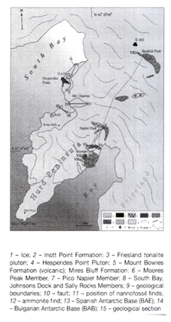 | 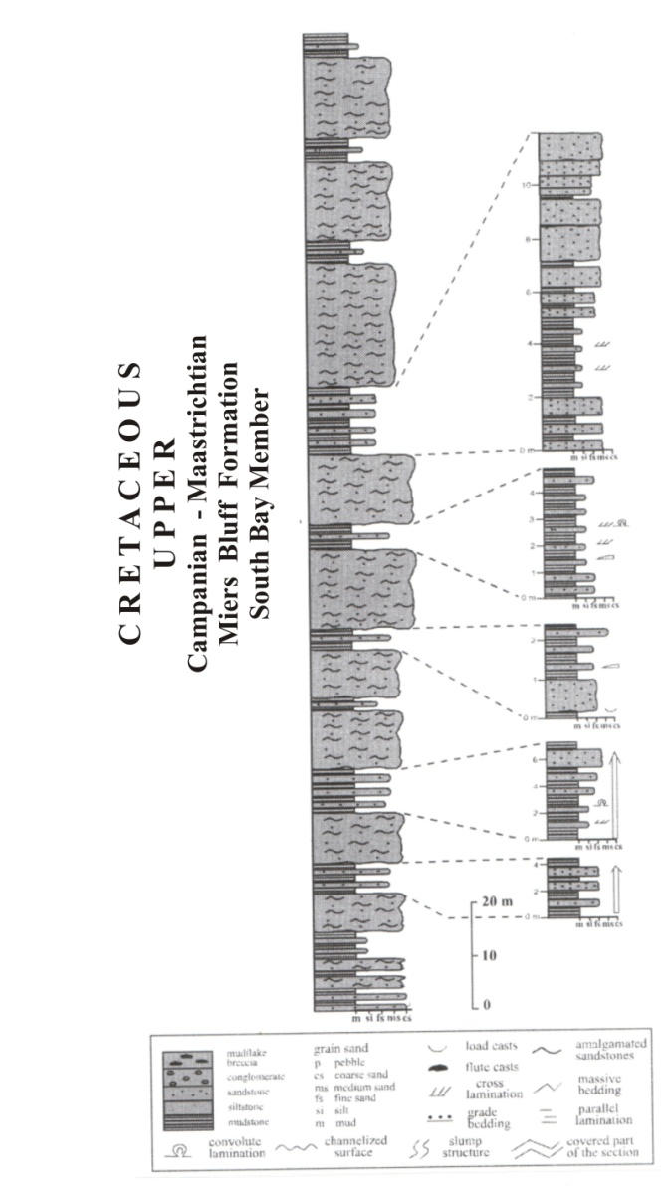

Fig. 1. Geological map of the Hurd Peninsula and sedimentary sequence section of the South Bay Member (Mires Bluff Formation) near to Bulgarian Antarctic Base (after Pimpirev et al., 2015).

Most of Livingston Island area is covered with glaciers and rock outcrop are exposed only along the shorelines just in restricted areas. The Hurd Peninsula has a rugged topography with low-rise hills, wide and gentle slopes and wide plains. Soil samples from the Livingstone Island were collected in the framework of 200 m around BAB area. The first sample (Sample 1-2015) was collected northern from the BAB, from the surface of original talus, with 40 m altitude and 210 m distance from the sea. The soil sample was clear of snow and ice. The place is free of plants, but 150 m around some lichens and mosses can be observed. The second sample (sample 2-2015) was taken southern of BAB from the surface of the area located 270 m from the sea and with 41 m altitude. The soil sample was dug under the moss’s roots and therefore free of plants. Thin grass vegetation, lichens and mosses can be observed near to the place of sampling. The situation of sampling areas and detailed information concerning the exact places are given in Figure 2 and Table 1. The rock bottom of both soil samples are represented by sedimentary and volcanic rocks and especially includes sandstones, siltstone, rarely mudstones and volcanic dykes, which commonly crossing them.

Table 1.
Geographical location, sampling date, distance from the sea and type of samples collected during the Antarctic Expedition
Samples | Date of sampling | Place of sampling | Latitude;  longitude | Distance from the sea, (m) | Altitude, (m) | Type of ample
1-2015 | 13. 01.2015 | Around BAB (Livingston Island) | 62°38. 401´S  60°21.799´W | 210 | 40 | Soil  (Sedi-  ment)
2-2015 |  |  | 62°38.512´S  60°21.959´W | 270 | 41 | Soil

a)
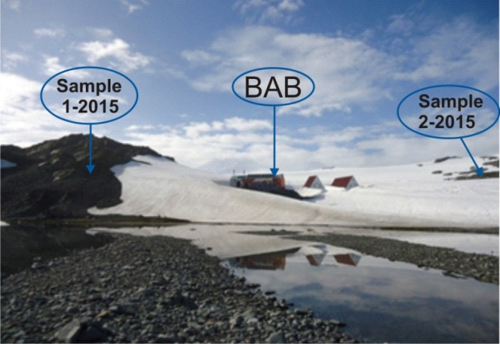
b)
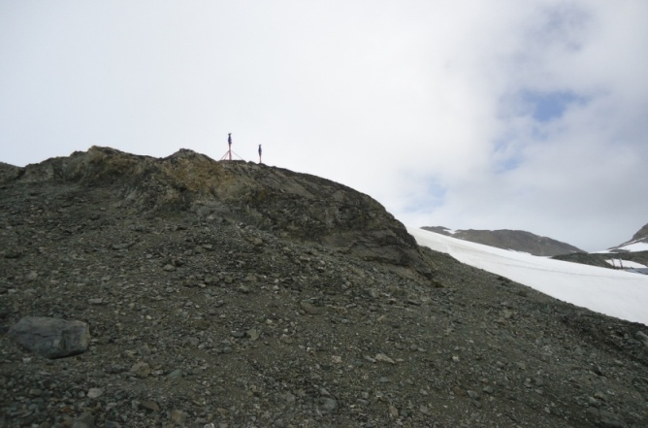
c)
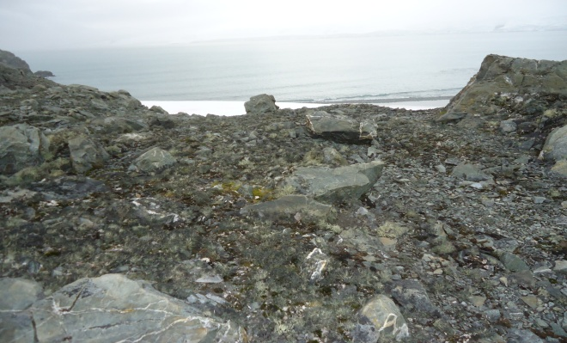

Fig. 2. The generat view of the Bulgarian Antarctic Base and the places of sampling. a) general view of the BAB and the places of sampling; b) the place of sample 1; c) the place of sample.

Analytical methods
The complex study of soil samples include characterization of organic matter, determination of main oxides, mineral composition and concentrations of 39 elements including rare earth elements (REE), heavy metals and other toxic trace elements were conducted in different laboratories.

The quality and composition of soil organic matter were determined according to the modified method of Turin (120 °С, 45 min, with catalyst Ag₂SO₄) and method of Kononova and Belchikova (Kononova, 1966; Filcheva and Tsadilas, 2002). Total humic and fulvic acids (C_{extractable}) were determined after extraction with mixed solution of 0.1 M Na₄ P₂ O₇ and 0.1 M NaOH. ‘Free’ and R₂O₃ bonded humic and fulvic acids (C_{NaOH}) – after extraction with 0.1 M NaOH and the most dynamic, low molecular fraction of organic matter, so called ‘aggressive’ fulvic acids fraction was extracted with 0.05 M H₂ SO₄, in ratio soil solution = 1:20 for the three extractions. Humic and fulvic acids in both extracts, C_{extractable} and C_{NaOH}, were separated by acidifying thе solution with sulfuric acid (0.5 M). Optical characteristics (E4/E6) show the degree of condensation and aromatization of humic acids. Optical characteristics of humic acids were measured on spectrometer SPECOL (absorption at λ 465 nm and 665 nm).

The mineral composition of soils was observed and determined by using optical microscopy Leica EZ4D and X-ray diffraction (XRD) in the Sofia University laboratories. Wet chemical analysis was applied for quantity specification of major oxide. The laser ablation inductively coupled plasma mass spectrometry (LA-ICP-MS) analyses were conducted at the Geological Institute of the Bulgarian Academy of Sciences for establishing of concentrations of 39 minor and trace elements of studied soil samples.

Results and Discussions

Content and composition of the organic matter
The first data on the soil organic carbon content and composition of the soil samples collected by the Bulgarian scientific expedition (1994/95 and 1995/96) were published by Sokolovska et al. (1996). Different investigations on the same soil samples were also published by Sokolovska et al. (2015). Studied soils were subdivided in three groups according the experimental data concerning the content and composition of soil organic matter. The authors marked their opinion on the initial stage of processes of humus formation and soil formation, which develop in very unfavourable conditions (Sokolovska, 1996).

In the framework of the present investigation the following parameters of soil organic matter was determined – concentration of total organic carbon, humic and fulvic acids, determination of different humic acid fractions (free of R₂O₃ and Ca-bearing complexes), unextracted organic carbon, extracted with 0,1N H₂SO₄ and 0,1N NaOH organic carbon and optical characteristics (E₄/E₆).

The data concerning the concentration and other main characteristic of organic matter of studied soils are given in Table 2. According to the classification of Grishina and Orlov (Orlov, 1985) and Artinova (2014) the total organic carbon (TOC) content in sample 1 is very low (0,98 %). The data presented by Lee et al. (2004) show the average organic carbon content in 30 soil samples from Barton Peninsula (grouped in four groups and based on bedrock type) - 0.76% with variation between 0.06 and 2.97%. Consequently, the degree of humification of sample 1 is low (under 10%). The humus is of humic type Ch/Cf = 2,60%, with predominance of humic acids over the fulvicacids (Orlov, 1985). These data are different from the data obtained by Sokolowska et al. (1996, 2015), for all Antarctic soil samples analysed before. The sample 1 is collected on the rock talus where the vegetation is presented mainly by lichen and mosses. In the vicinity of the sampling was observed separate grass tufts also. The data indicates an initial process of soil formation. Ca-complexed humic acids have an extremely low concentration (7.69%) compared to the total amount of humic acids. The humic acids are “free” or bound with R₂O₃, which are more mobile and could be leached. The unextractable organic carbon content is high (81.63%). The high unextractable organic carbon content is probably due to the strong bonds between the mineral and organic part of the soils. The optical characteristics which present the type if humic acids and their structure, show that humic acids are condensed and the ratio E₄/E₆ show average values according to classification of Grishina and Orlov (Orlov, 1985).

Table 2.
Content and composition of soil organic matter.
Sample № | TOC,% | Organic carbon, (%) |  |  | C_{h/}C_{f} | Organic carbon, (%) |  | Organic carbon, (%), Unextracted organic carbon Cres. (%) | Extracted with0.1N H₂SO₄(%)Organic carbon | Optical characteristics  (E₄/E₆ ) |  | Extracted with  0.1M NaOH ,(%)
 |  | Extracted with 0.1M Na₄P₂O₇+0.1M NaOH |  |  |  | Humic acid fractions |  |  |  | Total HA | “free” HA
 |  | total | HA | FA |  | free and R₂O₃ complexed | Ca-complexed
1 | 0.98 | 0.18 ª  18.37^{b} | 0.13  13.26 | 0.05  5.11 | 2.6 | 0.12  92.31^{c} | 0.01  7.69 | 0.80  81.63 | 0.04  4.08 | 5.08 | 4.39 | 0.16  16.33
2 | 0.52 | 0.08  15.38 | 0.00 | 0.08  15.38 | - | 0.00 | 0.00 | 0.44  84.62 | 0.02  3.85 | - | - | 0.07  13.46
a - % of the soil sample mass; b - % of the total carbon mass; c - % of the total humic acids; HA - humic acids, FA – fulvic acids. Optical characteristics - E₄/E_{6.}

The organic carbon content in sample 2 is extremely low (0,52 %) and the humus concentration is also low in comparison with data for sample 1. The results presented in Table 2 show that the humic acids practically absent in sample 2. Fulvic acids only are extracted, but in very low quantities. The quantity of the extracted organic substances in mixed solution of pyrophosphate, NaOH and NaOH extract are equal which confirm the data that in the soil sample 2, there is no humic acids and especially those bound with Ca. In conclusion it can be stated that in the studied soils from Livingston Island the processes of the humus- and soil formation are very primitive and just in initial stage. The low degree of poor organic materials humification of these Antarctic soils (especially in sample 2) is due to the very unfavourable climatic conditions on that place. In sample 2, the newly formed humus acids are not completely transformed into more mature products and just initial process of soil formation has been observed. The processes of polymerization and polycondensation, which form macromolecules of the new humus are not significant of both samples. Birds and penguin excrements play a significant role on the humus formation processes and probably influenced the humification process which obviously took place in greater extent in the soil from sample 1.

Morphology of the soils
The studied soil samples were subject to macro- and micromorphological observations under the optical microscopy and described according the methodology of Fitzpatrik (1984). Based on their previous investigations of Antarctic soils Ilieva and Groseva (1996) and Sokolovska et al. (2015) determined four group of Antarctic soils: 1) soils formed on rocks without vegetation; 2) soils formed under mosses (Drepanoducladus unsinatus); 3) soils under mixed moss-grass vegetation (Deshampsia Antarctica – Politrichum sp.) and 4) soils under Antarctic grass (Deshampsia Antarc-
tica). The macro- and micromorphological investigations of sample 2 (Fig. 3, c, d) reveal that it compose of unconsolidated mineral masses and grains and only small amount of plant roots which are dispersed among the rock fragments and penetrated to 3-4 cm in depth. The mineral grains include the particles of underlying sedimentary and volcanic rocks and petrographically represent mainly by quartz, рlagioclase, kaolinite and feldspars. The size of mineral grains and crystals vary from less than 0.1 mm to 1-2 cm and they are with angular or rounded shapes. Very small content of plant remains, represented by moss vegetation roots and mixed with mineral matter were also observed. Some very initial processes of decaying and transformation of the plant tissues, coincident with excreting vegetation biolites (the metter which occur in the plants and remain into the soil after their death) might be going pass. Considering the bright-brown to brown colour of vegetation tissue, it could be concluded that they were very slightly to slightly transformed and the processes of decay were uncompleted. Taking into consideration the above mentioned classification the studied soil sample 2 belongs to the second group “soils formed under mosses”. Macroscopic observations of sample 1 (Fig. 3, a, b), which was located on the surface of the rock talus under the moss and lichen vegetations and comparatively near to the sea shore, revile that the soil represents a close mixture of mineral grains, particles and fine rounded aggregates soldered with fine vegetation roots and other organic compounds (excrements of penguin and birds). The rock fragments are represented by fine grained quartz and plagioclase particles with very small sizes (from 100-500 µm to 1-2 mm) and rounded shapes. The organic matter includes small plant roofs and organic excrements. The soil masses of sample 1 are more compacted than sample 2. This symbiosis between rock fragments, vegetation remains, and organism’s excrements formed a peculiar week structure. The micro-morphological observation in 3-4 cm depth shows the following, although not very clear succession. On the soil surface fresh and very weakly decayed mosses and lichen with light-brown colour can be observed. The layer settles below consists of weakly to medium decayed fine roots. The lowest layer in the soil section is dark in colour and composes of greater amount of roots remains. Similar morphological and textural sequence, determined and reported by Sokolovska et al. (2015) for other Antarctic soil, resembles the morphology of a normally developed soil (Ilieva, 2011), but in the case of the Antarctic soils the separate layers are very much shortened.

a)  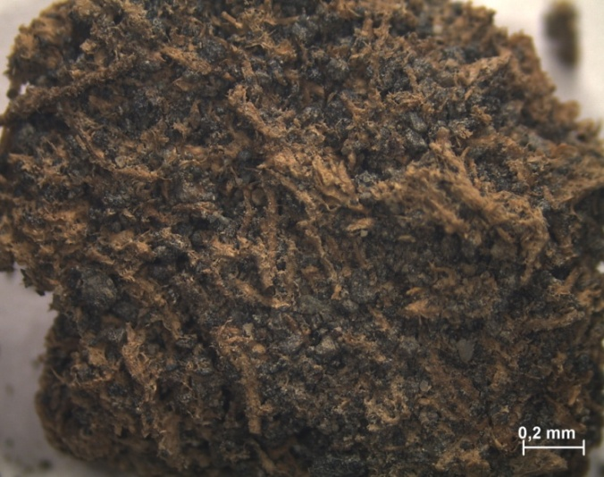 | b)  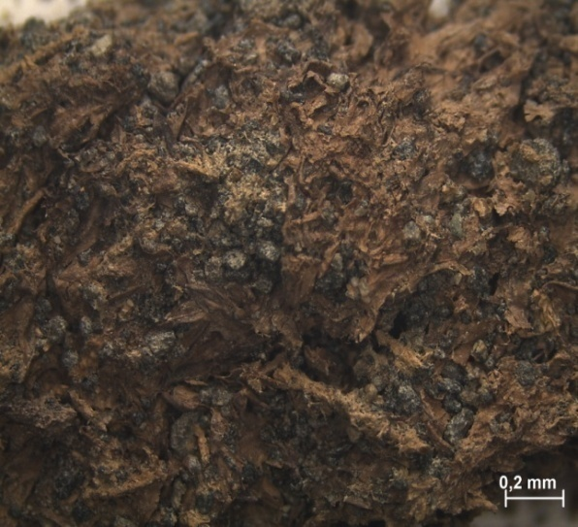
c)  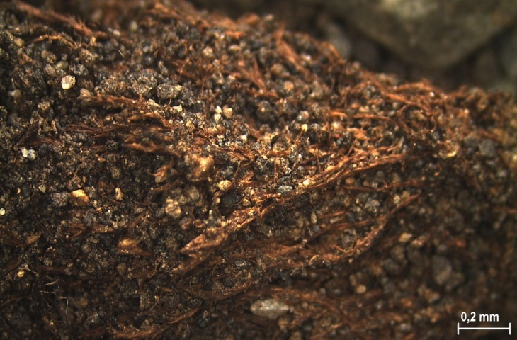 | d)  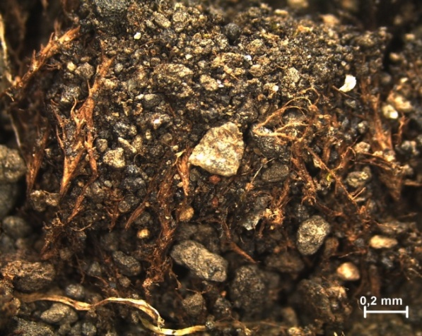

Fig. 3. Optical microscopy photos of soil samples. a) and b) sample 1; c) and d) sample 2.

Two soil layers, the first one consists of weakly to medium decayed plant tissues and the second one consists of black fine mixed biogenic remains and excrements can be easily distinguished in the studied samples. Taking into consideration the macro- and micromorphological investigations it can be concluded that there are evidences for more intensive biogenic processes which take place in soil sample 1 in comparison with sample 2. The data for total organic carbon and other characteristics of organic matter also confirm these circumstances (Table 2). According to the above mentioned classification the soils from sample 1 belongs to the third group “soils formed under mixed Antarctic vegetation”.

Mineralogical composition of soil samples
The chemical composition of soil (the main oxides) can be used to suggest the mineralogy in the soils, such as primary minerals or secondary weathering minerals. One approach to estimate the degree of chemical weathering is to use the Index of Compositional Variability (ICV) [ICV = (Fe₂O₃ + K₂O + Na₂O + CaO + MgO + MnO + TiO₂)/ Al₂O₃] (Cox et al., 1995). Nonclay minerals have a higher ratio of the major cations to Al₂O₃ than clay minerals so the nonclay minerals have a higher ICV index. For example, the ICV index decreases in the order of pyroxene and amphibole (̴ 10-100), biotite (̴ 8), K-feldspar (̴ 0,8-1), plagioclase (̴0,6), muscovite and illite (̴ 0,3), montmorilonite (̴ 0,13-0,3), and kaolinite (̴ 0,03-0,05) (Cox et al., 1995). Therefore, immature soils with a high percentage of nonclay silicate minerals will contain ICV values of greater than one. In contrast, more mature soils with mostly clay minerals formed under intensive weathering must to have lower ICV index values of less than one (Cox et al., 1995).

The ICV index values of studied soil samples from Livingston Island are shown in Table 3. The data are 1,8 for sample 1 and 1,6 for sample 2 and this indicating that Livingston Island soils are compositionally immature and dominated by nonclay silicate minerals. It can be concluded that they are formed under the physical disintegration of bedrocks and that components of chemical weathering product such as clay minerals are very minor, suggesting that the chemical weathering has not occurred significantly. Hence, most of the inorganic matter of the soils may have been produced by physical weathering and freeze and thaw processes especially. The similar data for Barton Peninsula soils in Antarctica have been reported by Lee et al. (2004).
The XRD analysis was applied in order to determine mineral matter in soil samples. The XRD spectra are presented in on Figure 4. The modes of mineral occurrence within the soils have been observed by optical microscopy. The minerals identified in the samples include quartz, plagioclase (albite), K-feldspar, kaolinite and magnetite. Quartz and plagioclase are very common in both samples, while feldspar and kaolinite are present in low amount. Quartz, plagioclase and feldspar usually occur as rounded or angular grains which size varies from microns to 1-2 mm. Irregular to ellipsoidal aggregates and masses of kaolinite closely mixed with other minerals and plant organic matter are also found in soils. Small magnetite grains dispersed among the soil matter was detected.
There is a close connection between the mineral composition of soils and the mineral composition of sediments (sandstones and siltstone), which compose the basement of the soils (Pimpirev et al., 2015). It can be concluded that the inorganic matter of studied soils may have been produced mainly by physical weathering of the rock formations of Livingston Island.

Table 3.
Major element compositions of Antarctic soil samples from Livingstone Island (weight %).
Samples | SiO₂ | TiO₂ | Al₂O₃ | Fe₂O₃ | FeO | MnO | MgO | CaO | Na₂O | K₂O | P₂O₅ | H₂O | Lost* | ICV**
1 | 52.20 | 1.58 | 16.39 | 3.66 | 5.84 | 0.12 | 4.42 | 7.42 | 4.68 | 1.11 | 0.62 | 0.17 | 1.85 | 1.8
2 | 54.17 | 1.52 | 16.07 | 4.32 | 4.52 | 0.13 | 3.89 | 5.38 | 4.15 | 2.04 | 0.57 | 0.43 | 2.70 | 1.6
* Weight lost during heating; ** ICV – Index of Compositional Variability [ICV = (Fe₂O₃ + K₂O + Na₂O + CaO + MgO + MnO + TiO₂)/ Al₂O₃] (Cox et al., 1995)

a)
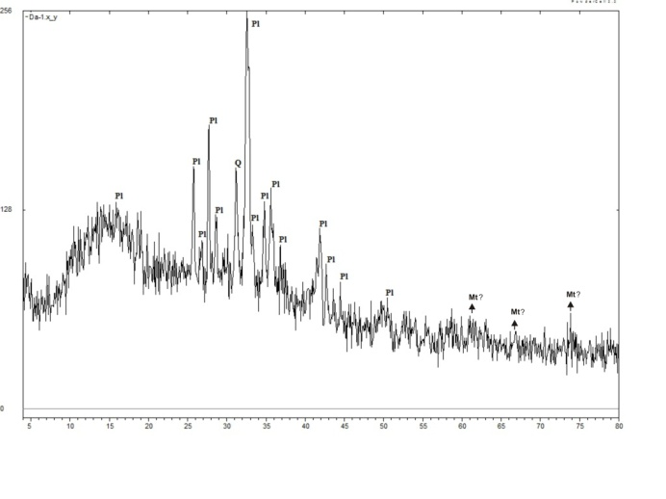
b)
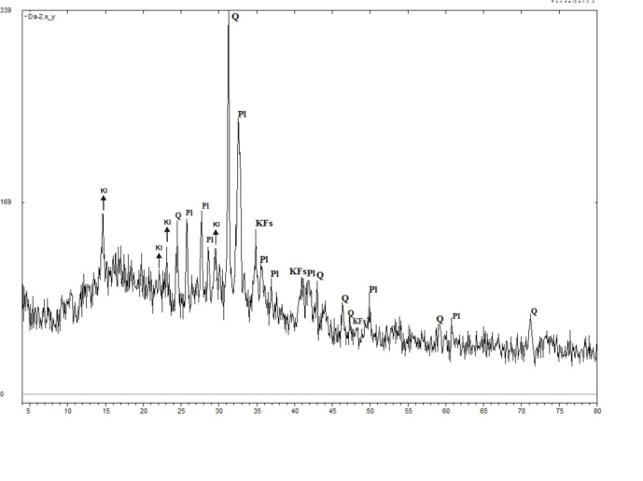
Fig. 4. XRD specters of soil samples. a) sample 1; b) sample 2.

Major, minor and trace elements in soils
The data for major oxides content are presented in Table 3. SiO₂ totally dominated, following by Al₂O₃ and other oxides (Fe₂O₃, FeO, K₂O, Na₂O, CaO, MgO, MnO, TiO₂ and P₂O₅) which are in smaller amount. These results confirm the assumption that the main part of the soils are form from the weathering sediments of the bedrocks composed mainly of sandstones and siltstones.

The concentrations of minor and trace elements including rare earth elements determined by using LA-ICP-MS are given in Table 4. In order to estimate and analyze the data for elements we use the Clarke value for sedimentary rocks, which are reported by Ketris and Yudovich (2009) and Renton et al. (1990) and the mean values of the elements given by Melandrino et al. (2009) for unpolluted soils and sediments.

The comparison between the average content of elements in the sedimentary rocks and the content in studied soil samples and taking into consideration the calculated enrichment/depletion factor (EDF) for each element of both samples, it appears that the most elements in soils are generally around or below the Clark values for the sediments (EDF ≤ 1), with the exception of Sc, V, Co, Cu, Zn, Ga, Sr, Cd and partly of As and Pb which exceed two, three or more times the average concentration for sedimentary rocks and which have EDF > 1. Regarding the REE only Eu and Er are concentrated two times and more than the Clarke values (Table 4).

Comparatively high content of some elements, including heavy metals, which are environmentally sensitive has been fixed in soils. The most abundant are Cd (EDF = 5,9 for sample 1 and 4,6 for sample 2), Zn (EDF = 4,6 for sample 2) and Pb (EDF = 3,6 for sample 2). Co (EDF = 2 for sample 1 and 1,7 for sample 2), Cu (EDF = 1,6 for both samples) and Sr (EDF = 1,5 for sample 1 and 1,1 for sample 2) also display concentration higher than Clarke values. The REE content is around Clarke values (EDF is a little bit below or above 1), except Eu, Er, Gd, Dy and Yb which EDF vary from 2,4 to 1,6. It makes impression that radioactive elements U and Th are rather below than Clarke values (Table 4).

In comparison with data for the unpolluted Antarctic soils and sediments (from Terra Nova Bay) published before by Malamdrino et al. (2009) and concerning heavy metals it can be conclude that the concentrations of Ni, Cu, Zn, Cd and partially of As, Pb and Cr (for the sample 2) in studied soils are increased. The highest content in studied soils has been determined for Cd (10 times higher), Zn (3 times higher), Pb (more than 2 times higher), Cu (2 times higher) and Ni (less than 2 times higher). If the same data had been interpret as a comparison with values for unpolluted sediments, published by the same authors, it makes clear that only Cd exceeded the maximum permissible value for sedimentary rocks. It must to note that such parallel is rather relative because the considerable geological and chemical differences between rock formations of that Antarctic areas.

Almost identical determination of different elements in sample 1 and sample 2 was established. Only Zn and Pb are present in higher concentrations in sample 2 (Zn is more than 4 times and Pb is more than 3 times higher) in comparison with sample 1.

Table 4.
Minor, trace and rare earth element concentrations of Antarctic soil samples from Livingstone Island (ppm). Clarke value, enrichment/depletion factor (EDF), mean values in unpolluted soils and sediments are also given. LA-ICP-MS.
Elements | Clarke value of sedimentary rocks* | Sample 1 | EDF¹ | Sample 2 | EDF² | Mean values in unpolluted soils** | Mean values in un-polluted sediments**
S | - | <1461 | - | <507 | - | - | -
Sc | 9.6 | 35.3 | 3.7 | 31.4 | 3.3 | - | -
V | 91 | 270 | 3.0 | 224 | 2.5 | - | -
Cr | 58 | 42.9 | 0.7 | 59.5 | 1.0 | 54 | 62
Co | 14 | 27.9 | 2.0 | 24.4 | 1.7 | - | -
Ni | 37 | 33.6 | 0.9 | 32.5 | 0.9 | 19 | 66
Cu | 31 | 50.0 | 1.6 | 50.8 | 1.6 | 25 | 45
Zn | 43 | 86.8 | 2.0 | 199.7 | 4.6 | - | -
Ga | 12 | 21.6 | 1.8 | 25.3 | 2.1 | - | -
As | 7.6 | <5.2 | <0.7 | 11.5 | 1.5 | 7.2 | -
Rb | 94 | 31.6 | 0.3 | 70.3 | 0.7 | - | -
Sr | 270 | 412 | 1.5 | 304 | 1.1 | - | -
Y | 29 | 33.8 | 1.2 | 35.0 | 1.2 | - | -
Zr | 170 | 184 | 1.1 | 176 | 1.0 | 60 | 118
Nb | 7.6 | 7.5 | 1.0 | 8.7 | 1.1 | - | -
Cd | 0.8 | 4.7 | 5.9 | 3.7 | 4.6 | 0.4 | 0.4
Sb | 1.2 | <1.1 | <0.9 | <0.4 | <0.3 | - | -
Cs | 7.7 | 1.3 | 0.2 | 3.0 | 0.4 | - | -
Ba | 410 | 197 | 0.5 | 350 | 0.8 | - | -
La | 32 | 16.6 | 0.5 | 22.3 | 0.7 | - | -
Ce | 52 | 39.5 | 0.7 | 49.1 | 0.9 | - | -
Pr | 6.8 | 5.3 | 0.8 | 6.1 | 0.9 | - | -
Nd | 24 | 24.2 | 1.0 | 26.8 | 1.1 | - | -
Sm | 5.5 | 6.0 | 1.1 | 6.5 | 1.2 | - | -
Eu | 0.9 | 1.9 | 2.1 | 1.8 | 2.0 | - | -
Gd | 4.0 | 7.0 | 1.8 | 6.9 | 1.7 | - | -
Tb | 0.7 | 1.1 | 1.5 | 0.9 | 1.3 | - | -
Dy | 3.6 | 6.2 | 1.7 | 6.2 | 1.7 | - | -
Ho | 0.9 | 1.1 | 1.2 | 1.2 | 1.3 | - | -
Er | 1.7 | 3.6 | 2.1 | 4.1 | 2.4 | - | -
Tm | 0.8 | 0.5 | 0.6 | 0.5 | 0.6 | - | -
Yb | 2.0 | 3.5 | 1.7 | 3.2 | 1.6 | - | -
Lu | 0.4 | 0.6 | 1.5 | 0.5 | 1.2 | - | -
Hf | 3.9 | 4.2 | 1.1 | 4.4 | 1.1 | - | -
Ta | 1.0 | 0.4 | 0.4 | 0.6 | 0.6 | - | -
W | 2.0 | <0.8 | <0.4 | 1.3 | 0.6 | - | -
Pb | 12 | 8.3 | 0.7 | 44.0 | 3.6 | 19 | 34
Th | 7.7 | 2.4 | 0.3 | 4.8 | 0.6 | - | -
U | 3.4 | 0.6 | 0.2 | 2.2 | 0.6 | - | -
* Clarke for sedimentary rocks after Ketris and Yudovich (2009) and Renov et al. (1990);
**Reported by Malandrino et al. (2009);
¹Soil/Clarke = EDF for sample 1;
²Soil/Clarke = EDF for sample 2;

In general, element concentrations in studied soil samples are influenced by element abundance of soil-forming sedimentary and partially volcanic rocks, which form the basement of soil cover at Livingston Island. The other factors like marine influence and the features of the corresponding catchment areas are also affect its chemical composition. The effect of vegetation for the chemical composition of soils is unclear and should be evaluated in detail in order to determine its influences mainly in Hurd Peninsula area.

Conclusion

Two soil samples from Livingston Island, South Antarctica have been studied morphologically, mineralogically and geochemically in order to understand soil formation processes and to determine concentrations of elements, some of them with great environmental importance.
The low content of TOC in both samples has been established. It is due to very scarce organic matter in the area of soil sampling. The processes of humus- and soil formation are very primitive and are in initial stage. The newly formed humus acids are not completely transformed into more mature products and just initial process of soil formation has been observed, especially in sample 1, where TOC is more abundant. The processes of polymerization and polycondensation, which form humus macromolecules are not significant for both samples. The sources of soil organic matter are scarce vegetation (mainly lichens, mosses and small amount of grass) remains and bird and penguin excrements, which obviously play an important role on the humus formation processes. The low degree of humification is also due to the presence of very unfavourable climatic conditions.
Morphological study shows that the soils are very slightly to slightly transformed and the processes of decay are uncompleted, but there is indications that more intensive biogenic processes take place in sample 1 in comparison with sample 2.
The minerals identified in the soils are quartz, plagioclase, K-feldspar, kaolinite and magnetite, but quartz and plagioclase are totally dominated. There is a close connection between the mineral composition of soils and sedimentary rocks of the Miers Bluff Formation, which composed mainly of sandstones and siltstone, and forms the rock basement of the sampled area. The inorganic matter of soils may have been produced mainly by physical weathering of these sediments. The most elements in soils are generally around or below the Clark values for the sediments, with the exception of Sc, V, Co, Cu, Zn, Ga, Sr, Cd and partly of As and Pb which exceed two, three or more times the average concentration for sedimentary rocks. From the REE only Eu and Er are concentrated two times and more than the Clarke values. The total concentrations of heavy metals and other toxic elements, although some increased amount of Cd, Zn, Pb, Sr and As do not show any definite evidence of local or global anthropogenic contamination.
In general, the sediments of rock basement and the soil sampled around them showed a similar mineralogical and chemical composition, as evidence that rock- and soil-weathering processes occur only during the worm summer period, when the sea-shore zone of the island are ice-free. In conclusion it can be summarized that the Antarctic soils need to be further surveyed, analyzed and examined.

Acknowledgments:
Great acknowledgments of the Sofia University ”St. Kl. Ohridski” Science Fund for the financial support to realize the present study.
References

Aislabie, J., R. Fraser, S. Duncan, R. Farrell. Effects of oil spills on microbial heterotrophs in Antarctic soils. – Polar Biology, 24, 2001. - 308–313.
Artinova N. Humus state of soils in Bulgaria. In: Soil organic matter and soil fertility of Bulgarian soils, Bulgarian Humic Substances Society, 2014. - 29-74.
Balks, M., R. Paetzold, J. Kimble, J. Aislabie, I. Campbell. Effects of hydrocarbon spills on the temperature and moisture regime of Cryosols in the Ross Sea region, Antarctica. - Antarct. Sci. 14, 2002. - 319–326.
Bonev, K., D. Dimov, N. Georgiev. Explanatory notes to the geological map of Hurd Peninsula, Livingston Island. - In: Bulgarian Antarctic Research, A Syntesis (Ed. Pimpirev, C. and N. Chipev), Sofia, “St. Kl. Ohridski” University Press, 2015. – 308-319.
Campbell, I., G. Claridge, D. Campbell, M. Balks. The soil environment. In: Priscu, J.(Ed.), Ecosystem Dynamics in a Polar Desert: The McMurdo Dry Valleys, Antarctica. Antarct. Res. Ser., 72. Amer. Geophys. Union, Washington, 1998. - 297–322.
Claridge, G., I. Campbell, H. Powell, Z. Amin, M. Balks. Heavy metal contamination in some soils of the McMurdo Sound region, Antarctica. – Antarctic Science, 7, 1995. - 9–14.
Claridge, G., I. Campbell, M. Balks. Movement of salts in Antarctic soils: experiments using lithium chloride. – Permafr. Periglac. Process. 10, 1999. - 223–233.
Convey P. The influence of environmental characteristics on life history attributes of Antarctic terrestrial biota. Biological Reviews of the Cambridge Philosophical Society, 71, 1996. - 191–225.
Cox R., D. Lowe, R. Cullers. The influence of sediment recycling and basement composition on evolution of mudrock chemistry in the southwestern United States. - Geochim.Cosmochim. Acta 59, 1995. - 2919–2940.
Filcheva, E., C. Tsadilas. Influence of Cliniptilolite and Compost on Soil Properties. - Communications of Soil Science and Plant Analysis, 33, 3-4, 2002. - 595-607.
FitzPatrick E.A. Micromorphology of Soils. London-New York, Chapman and Hall, 1984. - 433 p.
Ilieva R., M. Groseva. Morphrlogy of Soils from the Livingston Island, South Shetland Islands (the Antarctic). In: Bulgarian Antarctic Research Life Sciences, 1996. - 98–105.
Ilieva, R. Micro-morphology of the organic substance. - Soil Science, Agrochemistry and Ecology, 1–4, 2011. - 31–135 (in Bulgarian).
Ketris, M., Y. Yudovich. Estimations of Clarks for Carbonaceous biolithes: World averages for trace element content in black shales and coals. – Int. J. Coal Geology. 78, 2009. – 135-148.
Kononova, M. M. Soil Organic Matter. London, Pergammon Press, 1966. – 544 p.
Lee, Y., H. Lim, H. Yoon. Geochemistry of soils of King George Island, South Shetland Islands, West Antarctica: Implications for pedogenesis in cold polar regions. – Geochimica et Cosmochimica Acta, 68, 21, 2004. – 4319-4333.
Malandrino, M., O. Abollino, S. Buoso, C. Casalino, M. Gasparon, A. Giacomino, C. Gioia, E. Mentasti. Geochemical characterization of Antarctic soils and lacustrine sediments from Terra Nova Bay. – Microchemical Journal, 92, 2009. - 21–31.
Orlov, D. Chemistry of soils. Моscow University Press, Moscow, 1985. - 376 p.
Pickard, J. Antarctic Oasis, Terrestrial Environment and History of Vestfold Hills. Academic Press. 1986. – 387 p.
Pimpirev, C., K. Stoykova, M. Ivanov, D. Dimov. The sedimentary sequences of Hurd Peninsula, Livingston Island, South Shetland Islands: Part of the Late Jurassic- Cretaceous depositional history of the Antarctic Peninsula. – In: Futerrer, D., D. Damaske, G. Kleinschmidt, F. Tessensohn (Eds.). Antarctica: contribution to global earth sciences. Berlin etc.: Springer, 2006. – 247-252.
Pimpirev, C., P. Pavlishina, Y. Stefanov. Evidence for deltaic palaeoenvironments in the lowermost part of the Miers Bluff Formation, Livingston Island, Antarctica. In: Proceedings National Conference Geosciences, 2012. - 97–98.
Pimpirev, C., M. Ivanov, K. Stoykova. Stratigraphy of the Miers Bluff Formation, Hurd Peninsula, Livingston Island, Antarctica. In: Bulgarian Antarctic Research, A Syntesis (Ed. Pimpirev, C. and N. Chipev), Sofia, “St. Kl. Ohridski” University Press, 2015. – 33-39.
Prus, W., M. Fabianska, R. Labno. Geochemical markers of soil anthropogenic contaminants in polar scientific stations nearby (Antarctica, King George Island). – Science of the Total Environment, 518-519, 2015. – 266-279.
Renov, A. A. Yaroshevsky, A. Migdisov. Chemical Composition of the Earth’s Crust and Geochemical Balance of Main Elements. Nauka, Moscow, 1990. – 192 p.
Sheppard, D., I. Campbell, G. Claridge. Contamination of soils about Vanda Station, Antarctica. Institute of Geological and Nuclear Sciences, Lower Hutt, New Zealand. Report 40/20. 1994.
Sheppard, D., G. Claridge, I. Campbell. Metal contamination of soils at Scott Base. – Applied Geochemistry, 15, 2000. - 513–530.
Smellie, J., M. Liesa, J. Munos, F. Pallas, R. Willan. Lithostratigraphy of volcanic and sedimentary sequences in central Livingston Island, South Shetland Islands. – Antarctic Science, 7, 1995. - 99–113.
Sokolovska, M., L. Petrova, N. Chipev. Particulars of Humus Formation in Antarctic Soils: Factors, Mechanisms, Properties. – Bulgarian Antarctic Research: Life Sciences, 1, 1996. - 7–12.
Sokolovska, M., N. Chipev, R. Ilieva, M. Nustorova, L. Petrova, Z. Vergilov, R. Hristova, J. Bech. Soils in Livingston Island: Composition, properties and ecological aspects. - In: Bulgarian Antarctic Research, A Syntesis (Ed. Pimpirev, C. and N. Chipev), Sofia, “St. Kl. Ohridski” University Press, 2015. – 308-319.
Stoykova, K., C. Pimpirev, D. Dimov. Calcareous nannofossils from Miers Bluff Formation (Livingston Island, South Shetland Islands, Antarctica): first evidence for a Late Cretaceous age. - Journal of Nannoplankton Research, 24, 2, 2002. - 166–167.
Ugolini, F., J. Bockheim. Antarctic soils and soil formation in a changing environment: A review. – Geoderma, 144, 2008. – 1-8.

Статията е рецензирана от проф. дгн Калинка Маркова и препоръчана за публикуване от кат. „Геология и проучване на полезни изкопаеми”.

