ГОДИШНИК НА МИННО-ГЕОЛОЖКИЯ УНИВЕРСИТЕТ “СВ. ИВАН РИЛСКИ”, Том 57, Св. II, Добив и преработка на минерални суровини, 2014
ANNUAL OF THE UNIVERSITY OF MINING AND GEOLOGY “ST. IVAN RILSKI”, Vol. 57, Part ІI, Mining and Mineral processing, 2014

DESORPTION OF COPPER FROM LOADED ION-EXCHANGE RESIN LEWATIT AS A STAGE OF PROCESSING OF RICH-IN-COPPER BIOLEACHING SOLUTIONS

Plamen Georgiev¹, Stoyan Groudev¹, Irena Spasova¹, Marina Nicolova¹, Kalina Mihaylova,
Dejan Karamfilov²

¹University of Mining and Geology “St. Ivan Rilski”, 1700 Sofia, ps_georgiew@abv.bg
²BCM, Macedonia

ABSTRACT. The desorption of copper from loaded ion exchange resin LEWATIT into acidic solution was studied by means of batch and continuous mode experiments. Batch mode kinetics and isotherm studies were carried out to evaluate the effects of the initial concentration of sulfuric acid and temperature on the copper desorption. First order and second order equations rate were used to fit the experimental data. Langmuir desorption equation was employed to analyze the equilibrium data. The optimal conditions of copper desorption from the ion exchange resin LEWATIT were 120 g/l diluted sulfuric acid solution as desorption agent, aqueous: resin (A/R) ratio of 1:5, 30°C, and agitation time of 10 minutes The desorption of copper from loaded resin with diluted sulfuric acid (100 g/l) under continuous flow regime was studied at 2, 4, and 6 bed volume velocity (BVV/h). The breakthrough curves revealed as higher was the applied flow rate during the elution as lower was the copper desorption.

Keywords: copper, solvent extraction, stripping, kinetic, Kd

ДЕСОРБЦИЯ НА МЕД ОТ ОБОГАТЕНА ЙОНООБМЕННА СМОЛА LEWATIT КАТО ЕТАП ОТ ПРЕРАБОТКАТА НА МЕД-СЪДЪРЖАЩИ ПРОДУКЦИОННИ РАЗТВОРИ, ПОЛУЧЕНИ ПРИ ПРОЦЕСА НА БИОЛОГИЧНО ИЗЛУГВАНЕ
Пламен Георгиев¹, Стоян Грудев¹, Ирена Спасова¹, Марина Николова¹, Калина Михайлова, Деян Карамфилов²
¹Минно-геоложки университет „Св.Иван Рилски”, София 1700, ps_georgiew@abv.bg
²БММ, Македония

РЕЗЮМЕ. Десорбцията на мед от обогатена йонообменна смола LEWATIT в разтвор с кисело pH беше изследвана посредством опити с разбъркване и при проточен режим. Типът кинетика на процеса и особеностите на десорбцията на медта бяха определени, за да се разкрие влиянието на факторите начална концентрация на сярна киселина и температура върху десорбцията на мед. Уравнения от първи и втори ред бяха използвани за оценка на получените опитни данни. Уравнението на Лангмюир беше използвано за оценка на параметрите на десорбция. Оптималните условия за десорбция на мед от йонообменна смола LEWATIT бяха 120 g/l разтвор насярна киселина, отношение (A/R) 1:5 (йонобменна смола: воден разтвор), 30°C и време на разбъркване 10 минути. Десорбцията на мед от обогатена йонообменна смола беше изследвана в проточен режим при 2, 4 и 6 обемни скорости на разредения разтвор на сярна киселина (100 g/l). Получените криви на десорбция разкриха, че с нарастване на използваната обемна скорост на десорбиращия разтвор, десорбцията на мед намалява.

Introduction
Since the 1970`s hydrometallurgy, and especially biohydrometallurgy, plays a main role in processing of copper ores. This method technologically is based on three main consecutive processes – a process of leaching, a process of concentration of already leached copper, and process of electrowinning (Peacey et al., 2003). Chemolithotrophic bacteria Acidithiobacillus ferrooxidans, A. thiooxidans, and Leptospirllum ferrooxidans play main role in bacterial leaching of copper, iron, as well as other non-ferrous metals especially from low grade sulphide ores at low ambient temperature (5-40 °C) (Walting, 2006). The process is carried out at normal pressure and without using of strong chemical oxidants, which made the bacterial leaching more preferable, both from economical and environmental point of view, than pyrometallurgy. As a result, more than of 20 % of refined copper worldwide nowadays is produced via this technological route (Peacey et al., 2003).
However, the development and commercial application of biohydrometallurgy into the practice is dependent on the presence of effective methods for processing of already leached copper from the pregnant solutions. In the very beginning, the process of cementation on the surface of elemental zinc was applied widely into the practice (Ahmed et al., 2011). In years, it was replaced by means of processes of ion exchange and solvent extraction. Both alternatives are based on using of different highly selective reagents towards copper, or other non-ferrous heavy metals, presented in the pregnant solutions, which react with the relevant metal at higher rates in both direction - both of the process of concentration and the process of elution (stripping) of ion exchange resin and organic solvent, respectively. As a result, the processes of ion exchange and solvent extraction have had strong positive effect on the further development of biohydrometallurgy and its application in the processing of a
wide range raw materials (ores, concentrates, technogenic wastes, electronic scrap, etc.) enriched not only with copper but also with other non-ferrous metals, precious metals, etc., (Gericke and Govender, 2011; Groudev, 2013). At this moment, the suitable combination of these three processes (leaching, concentration, electrowinning) enable the hydrometallurgy to be adapted easily to raw materials with completely different chemical content of element(s) in interest as well as its (their) mineralogy (Peacey et al., 2003; Walting, 2006).
LEWATIT ion exchange resins are commercial products widely used into the practice not only for removal of non-ferrous metals from processing waters of different industries but also in dealkalization, softening, demineralization of natural and industrial waters, as well as for catalysis and processing of different organic compounds for production of foods or biodiesel (Guide, 2012).
The presence of aminophosphonic groups on the resin matrix and a negative surface charge which they carried as a result, determine the selective properties of ion exchange resins LEWATIT towards non-ferrous metals. It enables them to extract non-ferrous metals with higher selectivity also from solutions enriched with inorganic and organic compounds with excellent complexing properties – ammonia, aliphatic and aromatic amines, carboxylic acids (citric, gluconic, oxalic, etc.), diphosphates, polyphosphates, etc.,. The higher chemical stability made possiblе the ion exchange resin to be used at wide range of experimental conditions (pH = 0-14; t = (-20) – (+40 °C)).
The pregnant solutions from hydrometallurgy have some very specific quality – very high concentration (in range of 0.5 – 1.5 g/l) of one non-ferrous metal (two or even more non-ferrous metals could be presented at higher concentration in the pregnant solutions if concentrates being processed), higher concentration of iron (presented as ferrous and ferric ion), and higher concentration of sulfates. The main challenge to processing of such kind solutions is how to sorb preferentially the relevant non-ferrous metal from the solutions on the surface of exchange resin when the water acidity is higher (in range of 50 - 190 mmol/l) and within a few minutes (k₁ = 0.12-0.16, min⁻¹, (Walting, 2006)). When more than of 75-80 % of the sorption capacity of ion exchange resin is saturated, its regeneration is initiated by means of the resin treatment with suitable inorganic acid. By this way, already sorbed non-ferrous metals are desorbed and concentrate in solution with considerably lower volume than the initial volume of pregnant solutions generated as a result of bacterial leaching.
The article presents some results from a study about the effect of temperature and the content of sulfuric acid on the desorption of copper from loaded ion exchange resin LEWATIT realized by means of batch and continuous flow experiments.

Materials and methods
Sample from ion exchange resin LEWATIT, loaded with copper, ferrous and ferric iron ions, was supplied from BCM, where the bacterial leaching of low-grade copper ores is applied at industrial scale.
Total content of copper and iron in the loaded ion exchange
Table 1.
Effect of the concentration of sulfuric acid on the final concentration of copper in regenerate as a result of the copper desorption from loaded ion exchange resin LEWATIT*
Content of sulfuric acid in desorption solution, g/l | pH of regenerate | Cu in regenerate, mg/l | Efficiency of copper desorption, %
160 | - 0.15 | 2180 | 88.6
140 | - 0.07 | 2100 | 85.3
120 | 0.03 | 1955 | 79.5
100 | 0.12 | 1810 | 73.6
80 | 0.18 | 1580 | 64.2
* all experiments were carried out at temperature of 25° C

Table 2.
Effect of the content of sulfuric acid on copper desorption from LEWATIT
H₂SO₄, g/l | Parameter
 | Distribution coefficients, D | Preference factor,  K_{H+/Cu2+}
160 | 0.23 | 0.076
140 | 0.24 | 0.080
120 | 0.25 | 0.082
100 | 0.28 | 0.096
80 | 0.32 | 0.115

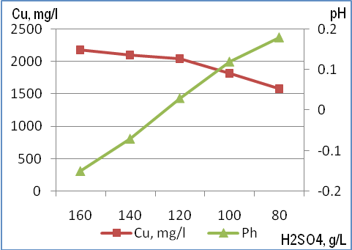

Fig.1. Effect of the content of sulfuric acid on the concentration of copper and pH of the regenerate solution as a result of elution of the loaded ion exchange resin LEWATIT
resin was determined by means of three consecutive stages of elution of a representative sample with diluted solution of H₂SO₄ (120 g/l). The aqueous phase after each stage of desorption was separated and the next stage of elution was initiated with a fresh solution of sulfuric acid. At the end, three solutions after the stripping of the ion exchange resin were combined and the content of copper and iron was determined. The concentration of copper was determined by means of photometric method based on the formation of color complex between cupric and ammonia ions. The intensity was measured by means of spectrophotometer MERCK SQ22.The content of ferrous and ferric iron was determined by means of their selective complexation with 5-sulfosalicilic acid at acidic and alkaline pH (APHA, 1995).

One liter of loaded ion exchange resin LEWEATIT contained 12300 mg of copper and 5370 mg iron, of which 2105 and 3265 mg were presented in ferric and ferrous state, respectively.
Batch tests for copper desorption were carried out in glass beakers (250 ml), the stirring was achieved by means of overhead stirrer FALC AT–M, the temperature during the test was maintained by means of a Julabo SW 22 water bath. The standard conditions for copper desorption which were applied at batch tests, if other conditions weren`t mentioned, were as follow: 300 rpm, 25 °C, aqueous:resin ration (A/R) 1:5, agitation time of 10 minutes. Diluted solutions of 96 % H₂SO₄ with different content of sulfuric acid were used as desorption agent. After each batch test, both phases were separated by means of filtration through glass wool and the content of copper and iron in the aqueous phase (regenerate) was determined by means of the above-mentioned methods. The spent ion exchange resin was rinsed with distilled water and the same experimental conditions as at the elution stage was applied. The aqueous phase (filtrate) was separated from ion exchange resin by means of filtration through glass wool. The percentage of copper desorption (D) was calculated by means of the equation:

D, % = (C₀ – Ce/ C₀)x100, (1)

where
C₀ and Ce are equilibrium concentration of copper on ion exchange resin before and after desorption (in mg/g), respectively.
pH and Eh were measured by means of a WTW pH-meters equipped with pH- and Eh-glass electrodes, respectively. Total acidity was determined by means of acid-base titration with 0.01 N NaOH till to pH 8.3.
The effect of concentration of sulfuric acid and temperature on the copper desorption from ion exchange resin LEWATIT was evaluated by means of first and second order rate equations (Lagergren, 1898; Ho et al., 2000).
A Langmuir desorption equation was employed to analyze the copper equilibrium data in dependence on the content of sulfuric acid (160, 140, 120, 100, and 80 g/L, respectively) in stripping solution or ambient temperature (10, 15, 20, 25, and 30 °C, respectively):

D_{e}/q_{e} = 1/K_{d}.D_{m} + D_{e}/D_{m}, (2)

where
D_{e}– amount of copper desorbed from ion exchange resin, mmol/L; D_{m} – maximum content of copper that could be desorbed at the relevant experimental conditions, mmol/ kg ion exchange resin. q_{e} – content of desorbed copper, mmol/kg ion exchange resin; K_{d} – constant, L /kg.
A Lineweaver-Burk regression method was applied to calculate Dm and Kd.
Energy of copper desorption was calculated in accordance to Singh & Tiwari (1997)method.
Copper desorption from loaded ion exchange resin at conditions of continuous flows were realized in glass funnels with cylindrical form which were supplied with a stop-cock on each end. Each funnel was charged with 70 g of ion exchange resin and diluted sulfuric acid was used (100 g/l) in the stripping process. The solution was directed through the glass
Table 3.
Kinetic of copper desorption from loaded ion exchange resin LEWATIT in dependence on the content of sulfuric acid evaluated by means of first order and second order rate equations
H₂SO₄, g/l | Equation parameters
 | First-order rate |  | Second-order rate
 | k₁, min⁻¹ | q_{e}, mg/g | k₂, g/mg.min | h, mg/g.min
160 | 0.159 | 12.17 | 0.0790 | 11.57
140 | 0.156 | 11.93 | 0.0803 | 11.43
120 | 0.140 | 11.42 | 0.0842 | 10.98
100 | 0.139 | 10.61 | 0,0938 | 10.56
80 | 0.138 | 8.77 | 0.1102 | 8.28

Table 4.
Constants and correlation coefficient for Langmuir isotherm of copper desorption from loaded ion exchange resin LEWATIT at different initial content of sulfuric acid
H₂SO₄, g/ | Isotherm parameters
 | q _{max}, mg/g | Kd, l/g | R²
160 | 9.30 | 5.62 x 10⁻⁴ | 0.941
140 | 8.97 | 5.85 x 10⁻⁴ | 0.950
120 | 8.85 | 6.03 x 10⁻⁴ | 0.941
100 | 7.18 | 6.74 x 10⁻⁴ | 0.945
80 | 6.62 | 7.32 x 10⁻⁴ | 0.931

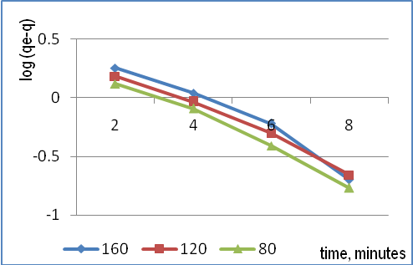

Fig.2. Fitting of experimental data for copper elution from loaded ion exchange resin LEWATIT to first-order equation rate

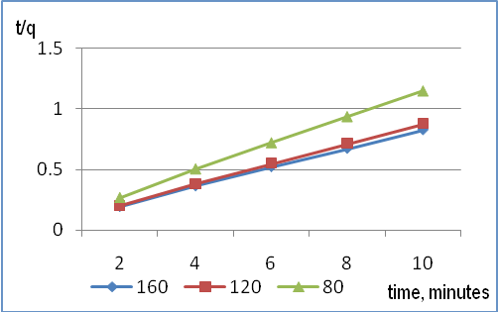

Fig.3. Fitting of experimental data for copper elution from loaded ion exchange resin LEWATIT to second order equation rate
Table 5.
Effect of temperature on the final concentration of copper in regenerate as a result of the copper desorption from loaded ion exchange resin LEWATIT*
Temperature, °C | pH of regenerate | Cu in raffinate, mg/ | Efficiency of copper desorption, %
10 | - 0.15 | 1790 | 72.7
15 | - 0.13 | 1880 | 76.4
20 | - 0.08 | 1960 | 79.7
25 | - 0.05 | 2005 | 81.5
30 | - 0.02 | 2035 | 82.7
*lthe resin elution was carried out with 120 g/l H₂SO₄

Table 6.
Effect of the ambient temperature on the copper desorption from LEWATIT with 120 g/l H₂SO₄
Temperature, °C | Parameter
 | Distribution coefficients, D | Preference factor,  K_{H+/Cu2}
10 | 0.27 | 0.043
15 | 0.26 | 0.053
20 | 0.24 | 0.072
25 | 0.24 | 0.078
30 | 0.23 | 0.077

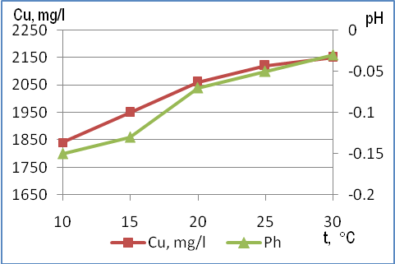

Fig.4. Effect of ambient temperature on the concentration of copper and pH of the regenerate solution as a result of elution of loaded ion exchange resin LEWATIT

funnels in an up-flow regime. The effect of different bed Volume Velocity (BVV) on the copper desorption was studied by means of an Ismatec FIXO peristaltic pump. The continuous flow experiment was realized in thermo chamber FINLUX at temperature of 15 °C. Collecting of eluate into the collecting tubes started when pH of solution, flowing out of the glass funnel, dropped to pH of 2.1-2.3.

RESULTS AND DISCUSSION
Most of copper mines and as follows copper leaching installations are situated in mountainous area where the ambient temperature varies considerably from season to season. The lower temperatures during the winter have a negative effect on the reactions` rates used for processing of
Table 7.
Kinetic of copper desorption from loaded ion exchange resin LEWATIT in dependence on temperature evaluated by means of first order and second order rate equations
t, °C | Equation parameters
 | First-order rate |  | Second-order rate
 | k₁, min⁻¹ | q_{e}, mg/g | k₂, g/mg.min | h, mg/g.min
10 | 0.152 | 10.22 | 0.936 | 9.72
15 | 0.147 | 10.83 | 0.0898 | 10.53
20 | 0.138 | 11.42 | 0.0842 | 10.98
25 | 0.139 | 11.88 | 0.0809 | 11.42
30 | 0.140 | 12.06 | 0.0806 | 11.60

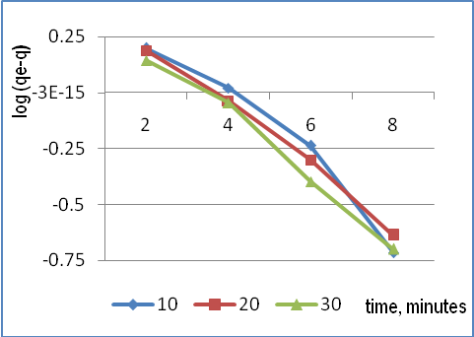

Fig.5. Fitting of experimental data for copper elution from loaded ion exchange resin LEWATIT to first-order equation rate

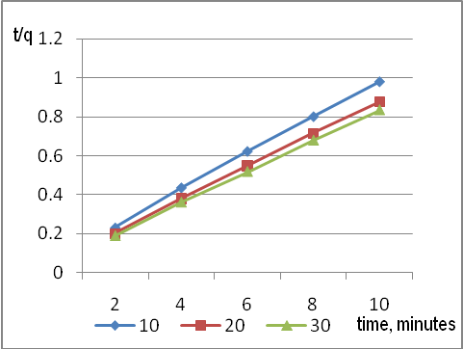

Fig.6. Fitting of experimental data for copper elution from loaded ion exchange resin LEWATIT to second order equation rate

copper containing pregnant solutions. That effect is usually compensated by means of higher content of acid during the stripping stage of the loaded resin as well as solvent compound. For that reason, the effect of ambient temperature and the content of sulfuric acid on the copper desorption from a loaded ion exchange resin were subject of that study.
Results for copper desorption from loaded ion exchange resin LEWATIT revealed that as higher was the acid content in the desorption solutions as higher was the content of desorbed copper (Table 1). For example, the content of copper in the stripping solution was 2180 and 1580 mg/l which were relevant
Table 8.
Constants and correlation coefficient for Langmuir isotherm of copper desorption from loaded ion exchange resin LEWATIT at different ambient temperature
t, °C | Isotherm parameters
 | D _{max}, mg/g | Kd, l/g | R²
10 | 7.63 | 6.55 x 10⁻⁴ | 0.962
15 | 7.94 | 6.33 x 10⁻⁴ | 0.958
20 | 8.81 | 6.05 x 10⁻⁴ | 0.941
25 | 9.20 | 5.70 x 10⁻⁴ | 0.968
30 | 9.52 | 5.21 x 10⁻⁴ | 0.948

to 88.6 and 64.2 % of copper desorption, when the elution was carried out with 160 g/l and 80 g/l sulfuric acid, respectively. It is interesting to note, that difference in the eluted copper from the resin was almost negligible at 160 and 140 g/l sulfuric acid. It was determined by the equal values of the Distribution coefficient as well as the Preference factor – 0.23-0.24 and 0.076-0.80, respectively (Table 2). If the acid content in the desorbing solutions further dropped, the values of both coefficients steadily increased which shown that a higher part of the surface negative charge of ion exchange resin was still saturated with cupric ions instead of hydrogen ions. For that reason, pH of the eluate steadily increased from slightly negative to slightly positive values (Table 1.). Similar trends were noticed also when the copper desorption kinetic were evaluated by means of first-order and second order rate equations. The higher rate of copper desorption (h) and higher values of the equilibrium concentration of copper in regenerate (q_{e}) were determined for 140 and 120 g/l sulfuric acid in the desorption solution (Table 3). However, the second-order equation rate fitted better to the experimental results in comparison to the way of fitting by first-order equation (Figure 2, 3). For example, R-squarred values of the results evaluated by means of second-order equation were in the range of 0.996-0.999 in comparison to 0.963-0.987 for the same results fitted by means of first-order equation rate. It underlined additionally the specific character of the selective way of copper adsorption on the ion exchange resin LEWATIT based on a valence connection between sorbent and sorbate. For that reason, protons were needed for its destruction in a way similar to an acidolysis mechanism, which is responsible for the metals leaching from their secondary minerals in environment.
Desorption behavior of copper from loaded ion exchange resin was fitted by means of Langmuir isotherm also. Regression analysis of the equation revealed that 9.302 mg copper per gram resin was the maximum amount (D _{max}) that could be desorbed with 160 g/l sulfuric acid at Kd of 5.62 x 10⁻⁴ L/ g(Table 4). However, higher concentration of sulfuric acid in the desorption solution are rarely used into the practice. The reason is that, after the resin surface is regenerated, the next cycle of copper sorption from the pregnant solutions can start after additional rinsing of the resin with water. During that process significant amount of free hydrogen ions are released into filtrate which is used later for irrigation of the low-grade copper ores being leached. As a result, a higher concentration of hydrogen is consumed in the dissolution of some ferric hydroxides when filtrate comes in a contact with the ore. It leads to a higher concentration of ferric ions in the pregnant solutions which have strong negative effect on the copper selective separation from pregnant solutions regardless of the
Table 9.
Effect of bed volume velocity (BVV) on copper desorption from loaded ion exchange resin LEWATIT at continuous flow regime
 | Bed volume velocity, BVV/h
 | 2.0 | 4.0 | 6.0
pH | 1.34 | 1.26 | 1.03
Acidity, mmol/l | 320 | 480 | 560
Cu, mg/l | 9660 | 8985 | 8240
Efficiency of copper desorption, % | 67.2 | 62.5 | 57.3

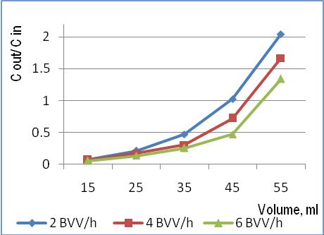

Fig.7. Breakthrough curves of copper desorption from loaded ion exchange resin LEWATIT with 100 g/l H₂SO₄, at 15 °C under continuous flow experiments

applied method - ion exchange or solvent extraction (Liebenberg et al., 2013; Georgiev et al., 2013).
It is well-known that temperature has a strong effect on the sorption as well as desorption of inorganic ions and organic compounds on inorganic as well as organic particles (Strawn and Sparks, 2000). For testing range, the higher ambient temperature enhanced greatly copper desorption from the loaded ion exchange resin. For example, 1790 mg and 2035 mg/l of copper were desorbed at 10 and 30 °C, respectively, which were relevant to 72.7 and 82.7 % efficiency of the desorption process (Table 5), respectively. All these experiments were carried out with 120 g/l sulfuric acid and as higher the ambient temperature was as higher concentration of hydrogen ions was consumed in the stripping process. As a result, pH of regenerate steadily increased from -0.15 to -0.02. The new equilibrium which was maintained during the batch test revealed that the preference factor K_{H+/Cu2} steadily increased with rising of temperature and the maximum value was reached at temperature of 25-30 °C (Table 6). However, the step of its increasing was considerably lower in comparison to the step of increasing of values of that factor when different concentrations of sulfuric acid were used in the resin`s elution (Table 2). It revealed that the content of sulfuric acid was the key parameter which determined copper behavior during the stripping process of the loaded ion exchange resin. According to the rate constants, the values varied in a narrow range (0.152-0.140 for k₁ and 0.0936-0.0806 for k₂) (Table 7). As in the first series of experiments, the experimental results fitted better to second-order equation rate (R²=0.998-0.999) in comparison to the first-order equation (Figures 5, 6). As it could expected, the higher rate of copper desorption (h=11.60 g/mg.min) for studied temperature range was measured at 30 °C. At that temperature, 9.52 mg was the maximum amount of copper (D _{max}), evaluated by means of Langmuir isotherm, which was desorbed from the resin (Table 8).
The thermodynamic parameters which include thermodynamic equilibrium constant (K°), standard free energy (∆G°), standard enthalpy (∆H°) and standard entropy (∆S°) put a light on the copper desorption from the loaded ion exchange resin. Within the study temperature range (10-30°C), the values of K° steadily increased from 2.67 to 4.79. The calculated standard free energy (∆G°) for all temperatures was negative (-2312 to -3957.23 kJ/mol) which had shown that copper desorbed spontaneous from loaded ion exchange resin if sufficient amount of hydrogen ions are presented in the stripping solution. In the same time, the value of standard enthalpy (∆H°) was positive which revealed that the process was endothermic.
The continuous flow experiments for copper desorption were carried out with 100 g/l sulfuric acid, at 15° C and 2.0, 4.0, and 6.0 bed volumes velocity (BVV) were tested as flow rates. That kind of experiment is quite similar to the real conditions at which copper is eluted from ion exchange resins at industrial leaching operations. The results shown in Table 9 revealed that when content of sulfuric acid in the stripping solution as well as the ambient temperature are constant, the efficiency of copper desorption is strongly determined by the applied bed volume velocity, i.e. by the residence time which hydrogen ions spent into the ion exchange column. For example, when 2.0 BVV/ h was applied the concentration of eluted copper reached 9660 mg/l. At 6 BVV/ h the content of eluted copper dropped down to 8240 mg/l. However, even at the lowest applied flow rate (2.0 BVV/ h) during that study, the efficiency of copper elution was lower than the results of batch experiment received at similar experimental conditions. For example, the efficiency of the process at 2BVV/h was 67.2 % (Table 9), while the efficiency of copper desorption at batch test at the same experimental conditions was 73.6 (Table 1). Those results underline the great importance of the applied flow regime on the copper desorption during the elution step of the loaded ion exchange resins at relevant temperature and content of sulfuric acid. On one hand, during the winter when the temperature of solutions being processed is the main limiting factor on the elution efficiency, it is preferable to applied smaller BVV (i.e. longer residence time). On other hand, during the periods of heavy rainfalls when is needed to process higher volumes of pregnant solutions daily, by means of combining of the higher content of sulfuric acid in the desorption solution and/ or higher BVV it is possible higher rate and efficiency of the copper stripping to be maintained. So, the stripping solutions with relatively constant characteristic (copper content, acidity, content of iron, etc.,) is possible to produce regardless of current climatic conditions.

CONCLUSIONS

- The batch tests results revealed that the copper desorption from loaded ion exchange resin LEWATIT fitted better to second-order equation rate.
- 100-120 g/L sulfuric acid and ambient temperature of 25-30 °C were optimal for copper elution from loaded ion exchange resin LEWATIT.
- Stripping solution with relatively constant properties and content of copper could be produced by sensible manipulation of the content of sulfuric acid as well as its flows rate through the ion exchange columns having in mind the current climatic conditions and the applied irrigation rate of the copper ore being leached.

REFERENCES
Ahmed, I.M., Y.A. El-Nadi, J.A. Daoud, J.A., 2011. Cementation of copper from spent copper-pickle sulfate solution by zinc ash. Hydrometallurgy 110, 62–66.
APHA. 1995. Standard methods for examination of water and wastewater. American Public Health Association, Washington, D.C.
Davenport, W.G., M. King, M. Schlesinger, A.K. Biswas. 2002. Extractive metallurgy of copper. 4th edition, Pergamon Press, pp. 11-14.
Gericke, M., and Y. Govender. 2011. Bioleaching strategies for the treatment of nickel-copper sulphide concentrates. Minerals Engineering 24, 1106-1112.
Georgiev, P., S. Groudev, I. Spasova, M. Nicolova, and A. Stryapunin. 2013. Selective separation of copper from rich-in-iron bioleaching solution by means of processes of solvent extraction with LIX 984 N and stripping with sulfuric acid. Annual of the University of Mining and Geology “St. Ivan Rilski”, vol.56, part II, pp. 69-74.
Groudev, S., I. Spasova, P.Georgiev, and M.Nicolova. 2013. Biological leaching of copper from a chalcopyrite concentrate at different temperatures. In: Proceedings of the XV Balkan Mineral Processing Congress, Sozopol, Bulgaria, ed. by I. Nishkov, I. Grigorova, and D. Mochev, vol.II, pp. 773-775.
Guide. 2012. Portfolio of Lewatit® ion exchange resins. LANXESS Deutschland GmbH.
Ho, Y.S., Ng, J.C.Y., McKay, G., 2000. Kinetics of pollutant sorption by biosorbents: Review. Separation and Purification Methods 29, 189–232.
Lagergren, S., 1898. About the theory of so called adsorption of soluble substances. Kungliga Svenska Vetenskapsakademiens Handlingar 24–4, 1–39.
Liebenberg, C.J., C. Dorfling, S.M. Bradshaw, G.A. Akdogan, J.J. Eksteen. 2013. The recovery of copper from a pregnant sulfuric acid bioleach solution with developmental resin Dow XUS43605. The Journal of the Southern African Institute of Mining and Metallurgy 113, 389-397.
Peacey J.I., X.J. Guo, S. Robles. 2003. Copper hydrometallurgy – current status, preliminary economics, future direction and positioning versus smelting. Copper 2003 – Cobre 2003, vol. VI, (Book 1) Santiago – Chile (P.A. Riveros, D. Dixon and D. Dreisinger, eds.).
Strawn, D.G. and D.L. Sparks. 2000. Effects of soil organic matter on the kinetics and mechanisms of Pb (II) sorption and desorption in soil. Soil Science Society of American Journal 64, 144-156.
Watling, H.R. 2006. The bioleaching of sulphide minerals with emphasis on copper sulphides – A Review. Hydrometallurgy 84, 81-108.

The article has been recommended for publication by department “Engineering Geoecology”.

