ГОДИШНИК НА МИННО-ГЕОЛОЖКИЯ УНИВЕРСИТЕТ “СВ. ИВАН РИЛСКИ”, Том 57, Св. IV, Хуманитарни и стопански науки, 2014
ANNUAL OF THE UNIVERSITY OF MINING AND GEOLOGY “ST. IVAN RILSKI”, Vol. 57, Part IV, Humanitarian sciences and Economics, 2014

THE RAW MATERIAL-RELATED CHALLENGES OF THE EUROPEAN UNION AND THE POSSIBLE CONTRIBUTION OF THE EAST- AND SOUTH-EAST EUROPE

Alfred Maier

Montanuniversitaet Leoben, 8700 Leoben, Austria, alfred.maier@unileoben.ac.at

ABSTRACT. The raw material-related challenges of the EU are tackled by a package of European initiatives and - for the first time since the European Community on Coal and Steel - positive signals for the raw materials sector and a political willingness for a re-industrialization of Europe can be observed. Compared with the world powers, the USA, China and Russia, the supply of the EU with existentially important mineral raw materials is clearly considerably lacking behind. Whereas, China, the USA and Russia produce about 47% of world trade of mineral raw materials (Iron and Ferro-Alloy, Non-Ferrous Metals, Precious Metals, Industrial Minerals & Mineral Fuels), the EU produces only 4.73%. These results do not only pose strategic risks to the EU´s supply, but also to the future industrial development of the EU, which, in any case, is in a critical phase of economic essential re-industrialization. In 2011 the reviewed group of 60 mineral raw materials showed a globally concentrated market (Herfindahl-Hirschmann Index > 2.000) for 33 mineral raw materials. More than 50% of the world mining productions of 48 mineral raw materials in this group are produced in only 3 countries. Whereas 75% of the world mining production of 27 mineral raw materials in this group are produced in also only 3 countries.

ПРЕДИЗВИКАТЕЛСТВАТА НА ЕС, СВЪРЗАНИ СЪС СУРОВИННИЯ ОТРАСЪЛ И ВЪЗМОЖНИЯ ПРИНОС НА ИЗТОЧНА И ЮГОИЗТОЧНА ЕВРОПА
Алфред Майер
Университет Леобен, 8700 Леобен, Австрия, alfred.maier@unileoben.ac.at

РЕЗЮМЕ. Предизвикателствата на ЕС, свързани със суровинния отрасъл са в пакет от европейски инициативи и за първи път от основаването на Европейската общност за въглища и стомана се наблюдават положителни отзиви за суровинния сектор, както и политическа воля за реиндустриализацията на Европа. В сравнение със световните сили, САЩ, Китай и Русия, запасите на ЕС със стратегически минерални суровини са значително по-малки. Докато Китай, САЩ и Русия произвеждат около 47% от минералните суровини на световния търговски пазар (желязо и железни сплави, цветни метали, благородни метали, индустриални суровини и горива), то за сравнение ЕС произвежда само 4.73%. Тези резултати не само показват стратегическите рискове за запасите на ЕС, но също и за бъдещото индустриално развитие на ЕС, което е в критична фаза. През 2011 г. бе разгледана група от 60 минерални суровини, като за 33 от тях се наблюдава съсредоточаване на световния пазар (на Херфиндал-Хиршман индекс > 2.000). Повече от 50% от световното минно производство на 48 минерални суровини от тази група е концентрирано само в три страни. Докато 75% от световния минен добив на 27 минерални суровини от тази група също е съсредоточено само в три страни.

The raw material-related challenges of the EU are tackled by a package of European initiatives and - for the first time since the European Community on Coal and Steel - positive signals for the raw materials sector and a political willingness for a re-industrialization of Europe can be observed.
Compared with the world powers, the USA, China and Russia, the supply of the EU with existentially important mineral raw materials is clearly considerably lacking behind. Whereas, China, the USA and Russia produce about 47% of world trade of mineral raw materials (Iron and Ferro-Alloy, Non-Ferrous Metals, Precious Metals, Industrial Minerals & Mineral Fuels), the EU produces only 5,5 %. These results do not only pose strategic risks to the EU´s supply, but also to the future industrial development of the EU, which, in any case, is in a critical phase of economic essential re-industrialization.
This contribution deals with
- Concentration of the Production
- Overview on the global production of mineral raw materials
- Production of the European Union
- Production of the East- and Southeast Europe
- Strategies for the ESEE Region
- Final remarks
The global extraction of mineral resources in overall is only to be estimated, because there is no global statistics for building materials. But for 63 minerals, that are produced on a global level and where there is a global market, statistics are available. This shows that the global extraction of minerals is about 40 billion t, a huge dimension of materials flow.
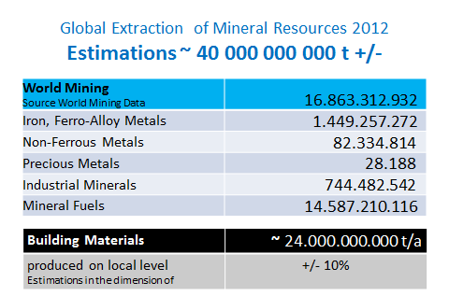
In 2012 the reviewed group of 63 mineral raw materials showed a globally concentrated market.
- 50 minerals: more than 50 % of the world production from only 3 countries
- 29 minerals: more than 75 % of the world production from only 3 countries
- 36 minerals: high concentration on the market (Herfindahl-Hirschmann Index > 2000)
- 28 minerals: China is the leading producer;
- Asia is the biggest producer of mineral raw materials.

In detail the world mining production is showed in the following pictures:
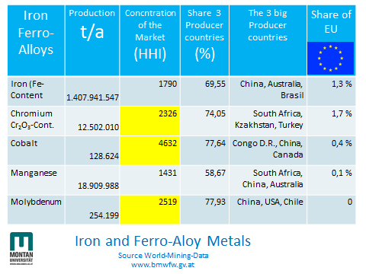

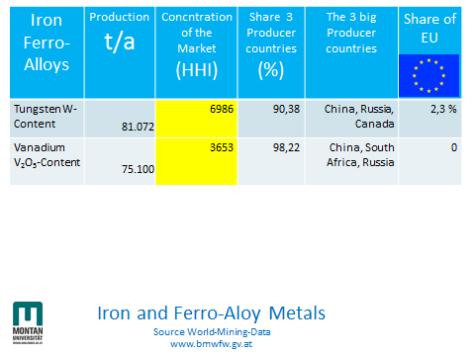

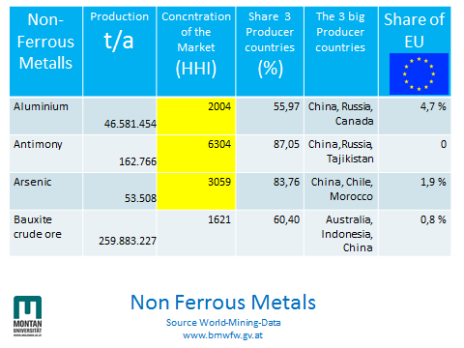
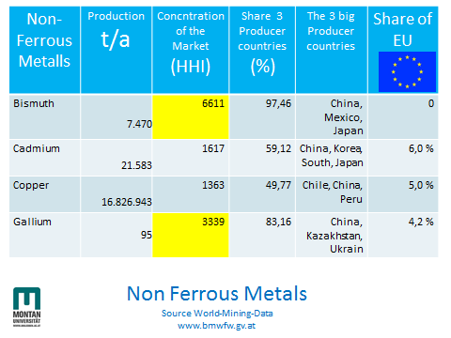
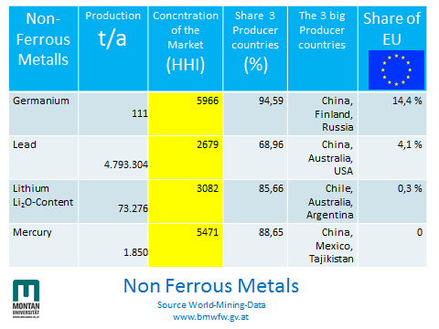
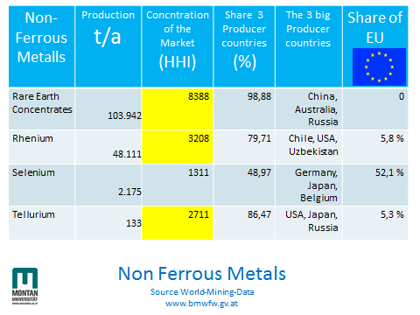

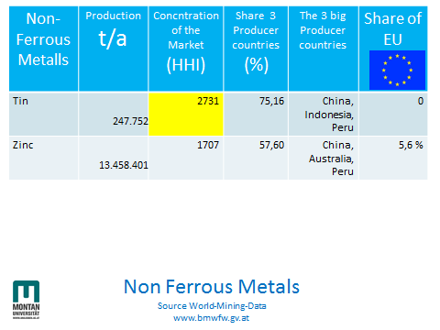
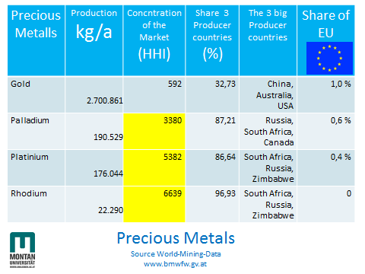
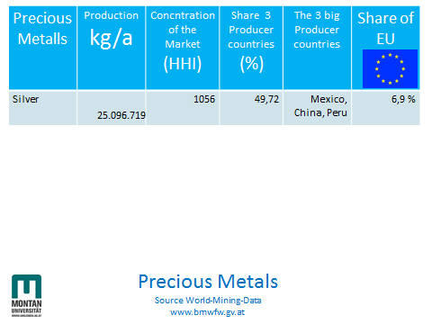
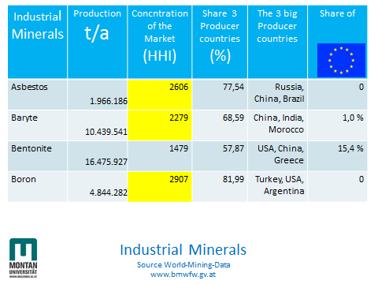
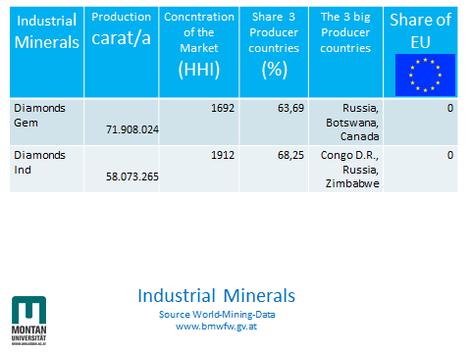
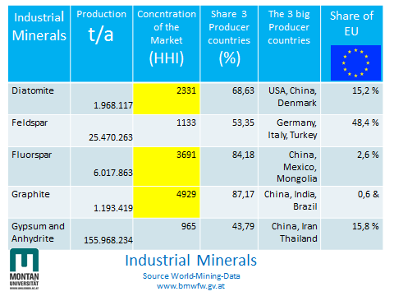
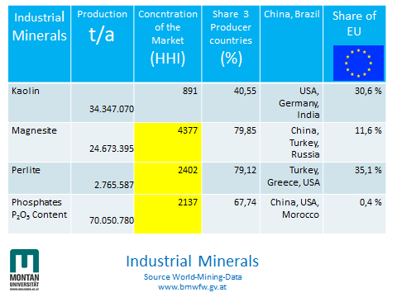
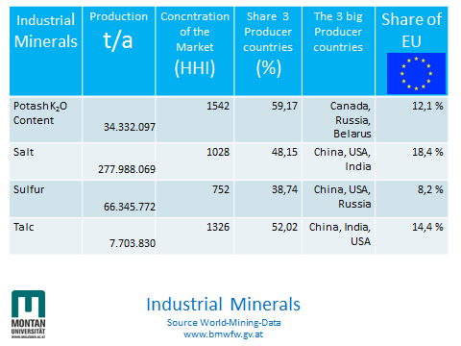

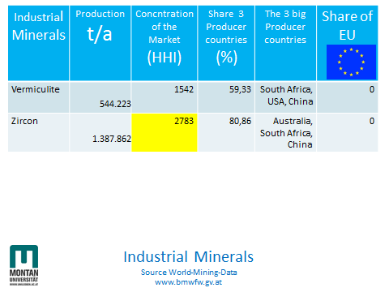
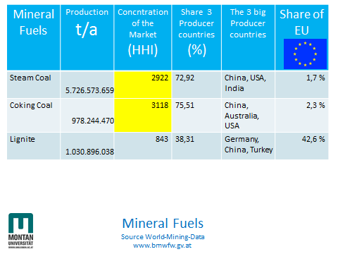
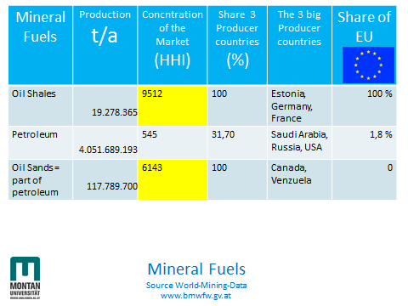
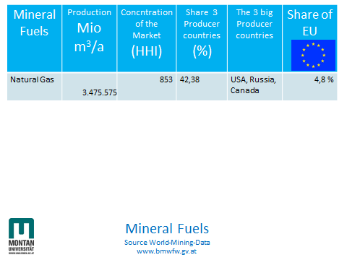

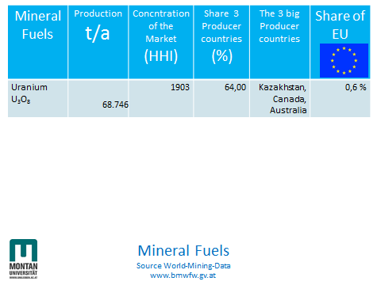

In overall the European Union is producing less than 1 billion t of mineral raw materials and has only a share of 5,5 % on the global extraction of minerals.
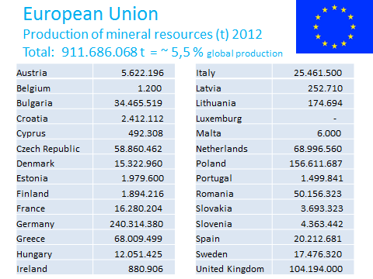

There are some concerns on the security of supply of the European Union and that has led to considerations on a list of critical raw materials; there is now a new list of critical raw materials shown by EC in 2014. And there is a need for that.
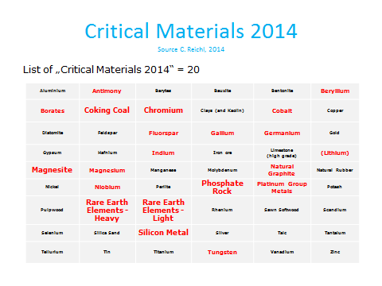
The ESEE region (“East & South-East Europe – Region”, where almost 100 million Europeans live in countries like Albania, Austria, Bosnia-Herzegovina, Bulgaria, Croatia, Cyprus, Czech Republic, Greece, Hungary, Kosovo, Montenegro, Macedonia, Romania, Serbia, Slovakia and Slovenia is of utmost importance to the European Union.
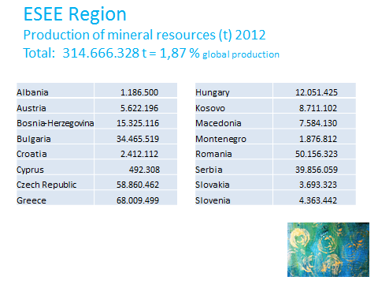
The ESEE region is of particular interest due to its unique geological potential and unique potential on secondary raw materials.
The RM potential overall and especially for some critical minerals like Antimony, Borates, Chromium, Gallium, Germanium, Indium, Magnesite, PGMs and REEs makes it highly relevant in connection with the European raw materials strategy.
From an economic point of view (security of supply, economic value, employment) and from a political point of view (cohesion, regional development, "Candidate Countries" and "Potential Candidates") the ESEE Region is highly relevant.
The ESEE region is geographically and culturally in the immediate and logical scope of the Montanuniversitaet. The promotion of sustainable development in the ESEE raw materials sector is a specific and motivating task for the Montanuniversitaet, which can also serve as an expert in terms of experience and skills. Thus, the Montanuniversitaet is strongly involved in these European initiatives. Within the consortium KIC Raw MatTERS (Tackling European Resource Sustainability) the Montanuniversitaet is currently developing an effective ESEE – cluster strategy on raw materials, for example:
- Forming a community of industry, research and universities in the ESEE Region
- Aiming at a comprehensive inventory of primary and secondary deposits, abandoned mines, mining enterprises, universities and R&D, reprocessing of known data
- Aiming at compressing information and feasibility studies to bridge the gap between high potentials and industrial activities, junior mining company concept
- Developing industrial projects from primary and secondary resources to generate an added value for the ESEE Region in terms of economic value and in terms of employment
- Developing new mining design for small scale mining
- Exchange of information on Horizon 2020, European Regional Development Fund, European Social fund, Cohesion Fund
And even when the ESEE region could add a lot of secure supply with minerals, there will be left a need for
- a fair and sustainable supply with minerals from the global markets,
- a sustainable supply with minerals from an own European production
- and strong efforts on resource-efficiency and substitution of materials.

Recommended for publication by Editorial board.

“The Herfindahl-Hirschman Index (HHI) is a commonly accepted and used measure of market concentration. It is calculated by squaring the market share of each firm competing in the market and then summing the resulting numbers. Only one firm means 100% market share. In this case the HHI would equal 10.000 (1002), indicating a monopoly. A market consisting of four firms with shares of 30%, 20%, 10% and 5%, results in a HHI of (30² +20²+10²+5²)= 1425. The HHI takes into account the relative size and distribution of the firms in a market and approaches zero when a market consists of a large number of firms of relatively equal size. The HHI increases both as the number of firms in the market decreases and as the disparity in size between those firms increases. In the United States markets in which the HHI is between 1000 and 1800 points are considered to be moderately concentrated, and those in which the HHI is in excess of 1800 points are considered to be concentrated. In the EU the threshold to concentrated markets is 2000. The concentration of producer countries is calculated by the HHI similarly to the firms index.” (Source World Mining Data, www.bmwfw.gv.at)

