ГОДИШНИК НА МИННО-ГЕОЛОЖКИЯ УНИВЕРСИТЕТ “СВ. ИВАН РИЛСКИ”, Том 58, Св. II, Добив и преработка на минерални суровини, 2015
ANNUAL OF THE UNIVERSITY OF MINING AND GEOLOGY “ST. IVAN RILSKI”, Vol. 58, Part ІI, Mining and Mineral processing, 2015

COMPUTATIONAL METHODS FOR VENTILATION NETWORKS MANAGEMENT

Doru Cioclea, Constantin Lupu, Ion Gherghe, Florin Rădoi, Vlad Mihai Păsculescu

National Institute for Research and Development in Mine Safety and Protection to Explosion – INSEMEX, 332047 Petroşani, Romania; doru.cioclea@insemex.ro; constantin.lupu@insemex.ro; ion.gherge@insemex.ro; florin.radoi@insemex.ro; vlad.pasculescu@insemex.ro

ABSTRACT. Mining ventilation is an extremely sensitive and complex domain which includes a variety of disciplines aimed for supporting and maintaining underground safety conditions. In this regard, solving ventilation networks using computational techniques is a giant step forward which provides the specialists to view in real-time the changes occurred on the network and, what is the most important, to anticipate possible perturbations in the ventilation system. The network of mine workings required for the exploitation of minerals is of a high complexity level, with different shapes and sizes and which may reach tens of kilometres in length. For achieving proper ventilation for each mine working is required the optimization of air flow reparation over each branch of the ventilation network. In this regard is required the solving of the ventilation network at the level of the entire mine. Worldwide are used for solving ventilation networks advanced IT equipment and specialized software such as 3D CANVENT, VENTSIM Visual Advanced, VENT-GRAF, VENPRI, Mine Ventilation Services, Venet PC, Duct SIM, Clim SIM, MIVENA, VUMA, ICAMPS Mine Vent etc. An example of a complex ventilation network belonging to Lupeni mine unit which is analysed using VENTSIM Visual Advanced is presented.

Key words: modelling, simulation, solving, ventilation, ventilation network

ИЗЧИСЛИТЕЛНИ МЕТОДИ ПРИ УПРАВЛЕНИЕ НА ВЕНТИЛАЦИОННИ МРЕЖИ
Дору Циоклеа, Константин Лупу, Йон Черге, Флорин Радой, Влад Михай Паскулеску
Национален научно-изследователски институт по минна безопасност и защита от експлозии – INSEMEX, 332047 Петрошани, Румъния; doru.cioclea@insemex.ro; constantin.lupu@insemex.ro; ion.gherge@insemex.ro; florin.radoi@insemex.ro; vlad.pasculescu@insemex.ro

РЕЗЮМЕ. Минната вентилация е изключително чувствителна и сложна област, която включва серия от дисциплини, насочени към поддържане на безопасни условия на труд при подземния добив. В това отношение, решаването на вентилационни мрежи чрез използването на изчислителни техники е гигантска стъпка напред, която дава възможност на специалистите да виждат в реално време настъпилите промени в мрежата и, което е най-важно, да предвиждат възможни отклонения във вентилационната система. Мрежата от минни изработки, необходима при добива на полезни изкопаеми, е много сложна, с различни форми и размери и може да достигне дължина от десетки километри. За постигането на добра вентилация във всяка от минните изработки е необходимо оптимизиране на ремонтните дейности за осигуряване на въздушния поток във всяко разклонение на вентилационната мрежа. По тази причина се налага решаването на вентилационната мрежа в целия рудник. При справянето с тези проблеми в света се използва модерно ИТ оборудване и специализиран софтуер като: 3D CANVENT, VENTSIM Visual Advanced, VENT-GRAF, VENPRI, Mine Ventilation Services, Venet PC, Duct SIM, Clim SIM, MIVENA, VUMA, ICAMPS Mine Vent и др. Представен е пример за комплексна вентилационна мрежа в рудник Лупени, която е анализирана чрез VENTSIM Visual Advanced.

Ключови думи: моделиране, симулация, решение, вентилация, вентилационна мрежа

Introduction

The main measure for ensuring optimal occupational health and safety conditions in underground hard coal mining is the achievement of proper ventilation (Baltaretu and Teodorescu, 1971; Teodorescu et al., 1980)
The ventilation of mine workings aims to achieve four main objectives:
- Ensuring the oxygen concentration required for underground staff;
- Diluting explosive and/or toxic gases which may occur in the network of mine workings (Cioclea, 2011);
- Exhausting the heat resulting from the human activity, respectively the geo-thermal gradient which is released into the network of mine workings;
- Exhausting humidity from underground into the atmosphere.
For achieving an efficient ventilation at the level of each mine working there is imposed the optimization of air flow repartition in each branch of the network, fact due to which is required the solving of the entire mine’s ventilation network.
For solving ventilation networks is required the processing of a high amount of data, therefore are currently used specialized software operating on specific IT equipment.

Lupeni mine unit ventilation network

Lupeni mine unit is located in the western part of Jiu Valley coal basin. The ventilation network of Lupeni mine is complex and comprises mine workings for connection with the surface and horizontal mine workings disposed over several horizons (horizon 300, horizon 400, horizon 480 and horizon 650). Fresh air entrance into the underground is achieved through 5 mine workings, namely: Stefan shaft, shaft no. 12, shaft with skip, coast gallery horizon 650 and auxiliary shaft South.
Underground mine workings are ventilated under the depression of two main ventilation stations: Main ventilation station Central Rising, equipped with two axial fans VOKD 1.8 and main ventilation station Shaft 1 East equipped with two axial fans type VOD 3.0.
Lupeni mine unit has five longwalls in exploitation (Covaci, 1983; Craciunescu et al., 1993) as follows: longwall with undermined coal bed Panel 1, seam 3, Block II Sublevel II, longwall with undermined coal bed Panel 1, seam 3, Block II Sublevel III, longwall with undermined coal bed Panel 11, seam 3, Block V, longwall with undermined coal bed Panel 3, seam 3, Block V and longwall with mechanized complex Panel 2C, seam 3, Block IV.

VENTSIM Visual Advanced software

For modelling and solving Lupeni mine ventilation network was used VENTSIM Visual Advanced software (User Guide, 2012).
Ventsim Visual Advanced has been developed for responding to the requirements for simulating and designing underground environmental conditions (Patterson, 1992; Le Roux, 1990) in order to ensure proper conditions for miners and equipment. Firstly, it has been designed as a ventilation tool which may operate independently of other software for mine planning, but it ensures a high compatibility level. Ventsim Visual ™ provides a set of integrated tools for the analysis of air flows, heat input, contaminants and financial aspects of mining ventilation.

Ventilation network solving

For modelling and solving Lupeni mine unit ventilation network was used the database of geodesic coordinates specific for structural changes of the ventilation network (Cioclea et al., 2013; Gherghe, 2004; Annual ventilation project, 2015), respectively air flow and pressure measurements carried out on site. After the input of geodesic coordinates into the database of Ventsim Visual Advanced, it calculates automatically the spatial distance between two consecutive junctions and instantly draws up the specific branch.
After modelling the ventilation network in 3D there are inserted for each branch the technical data, respectively profile and shape of mine workings and ventilation constructions. The next phase consisted in the input of parameters for the fans located in main ventilation stations, by inputting onto the software’s database the aerodynamic parameters specific for each fan in accordance with individual characteristic curves.
Following the previously mentioned phases, the ventilation network is balanced and solved and the animation is activated for air flows and fans from the main ventilation stations. In this phase are available information specific for each branch, the modelled and solved network is prepared for performing each simulation required.
For solving the ventilation network of Lupeni mine were inserted 386 junctions and 481 branches.
Figure 1 presents the 3D ventilation network of Lupeni mine unit. Figures 2 to 6 present details from the ventilation network of Lupeni mine unit, representing the areas of active longwalls with undermined coal bed Panel 1/3/II Sublevel II, Panel 1/3/II Sublevel III, Panel 3/3/V and the longwall with mechanized complex Panel 2C/3/V.

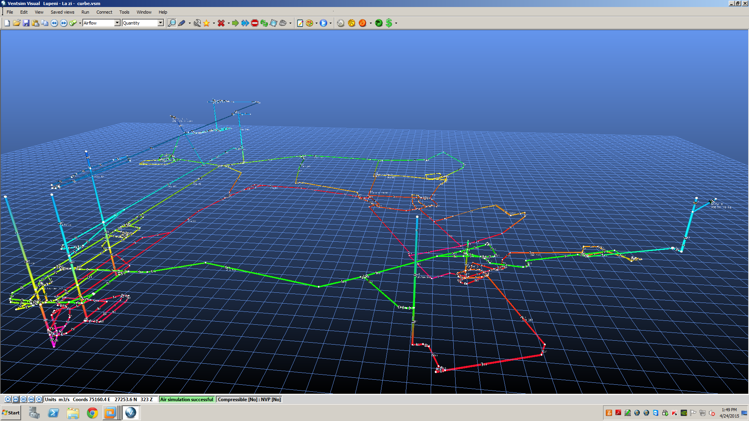
Fig. 1. 3D ventilation network of Lupeni mine unit

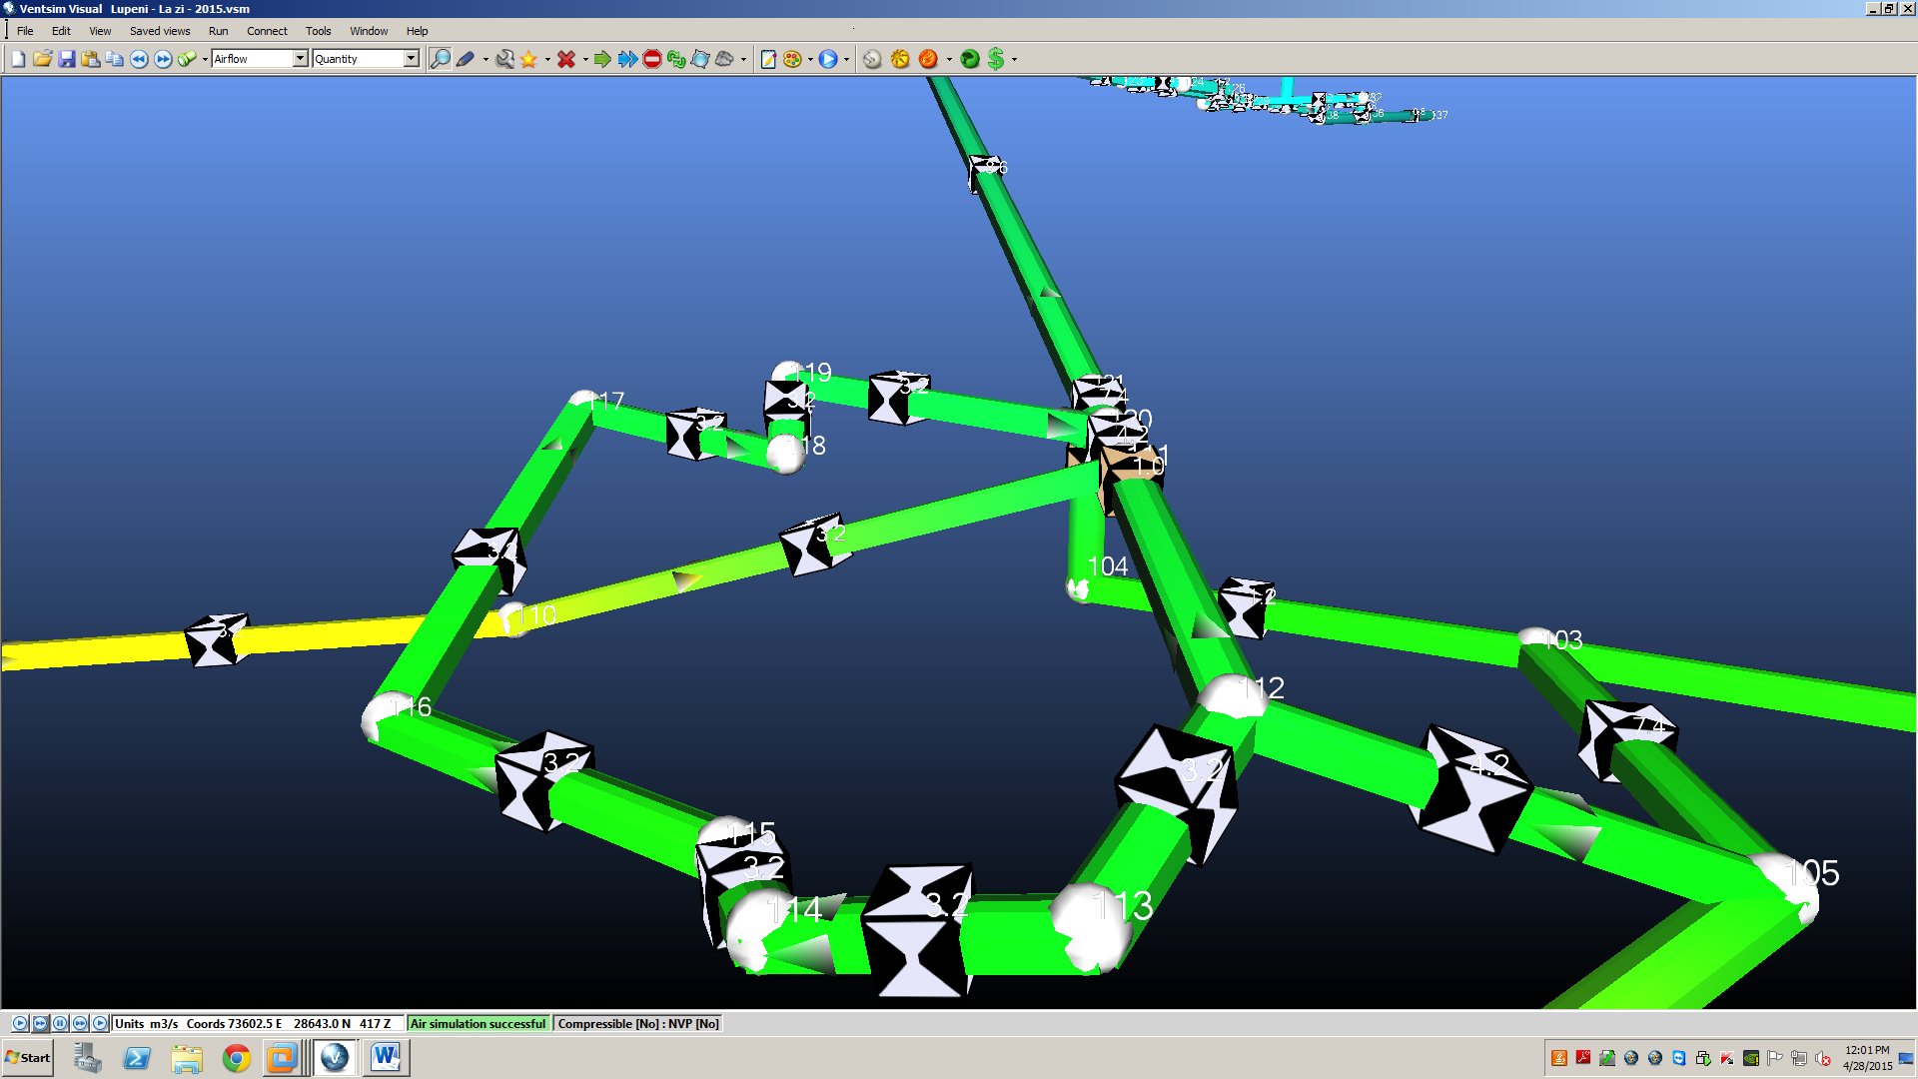
Fig. 2. Detail-longwall with undermined coal bed Panel 1/3/II Sublevel II

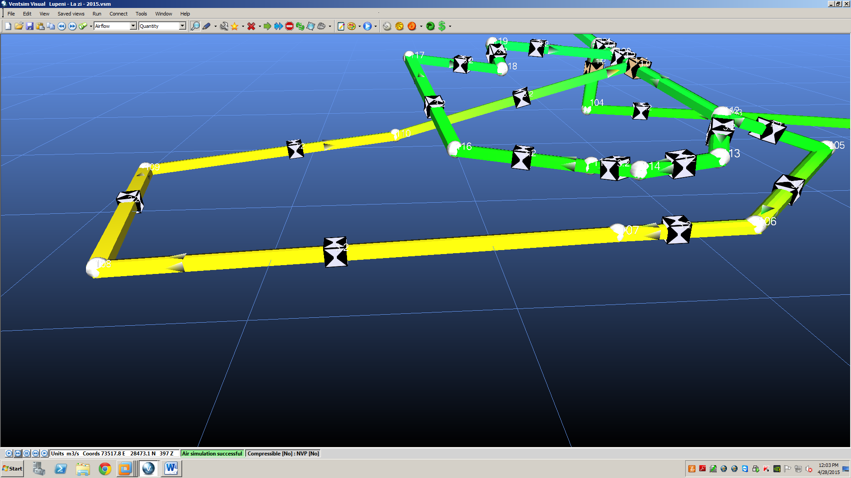
Fig. 3. Detail-longwall with undermined coal bed Panel 1/3/II Sublevel III

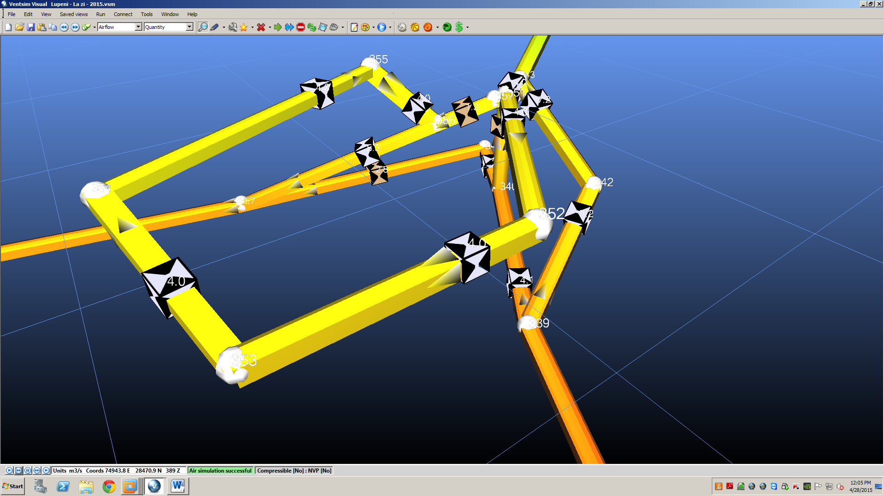
Fig. 4. Detail-longwall with undermined coal bed Panel 11/3/V

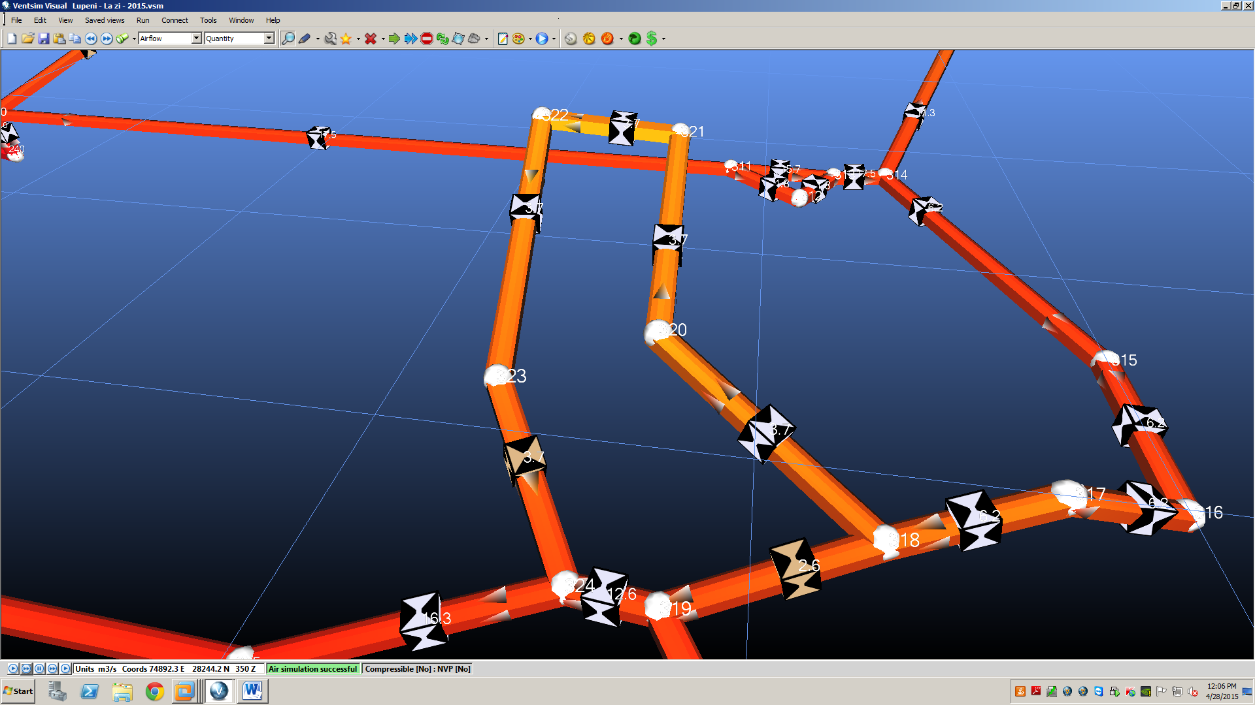
Fig. 5. Detail-longwall with undermined coal bed Panel 3/3/V

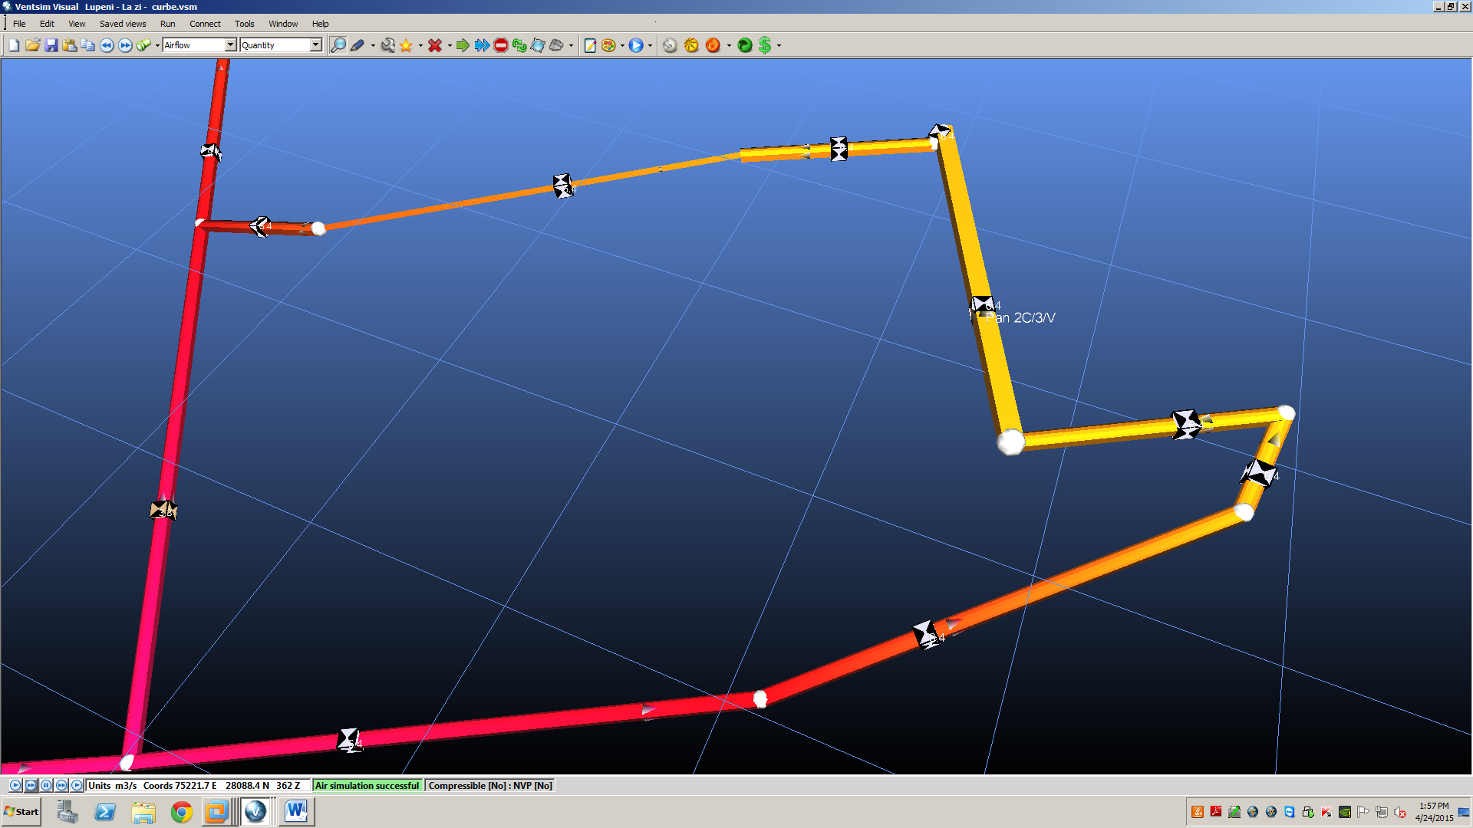
Fig. 6. Detail-longwall with mechanized complex Panel 2C/3/V

Following the ventilation network’s solving resulted the following:
- Air flow on the fresh air supply circuit at horizons 650, 480, 400, 300, branches with unique number 587, 267, 481, 410, 343, 115, 288, was of 85.4 m³ / s.
- Air flow at the level of the longwall with undermined coal bed no. 1, seam 3, bl. II Sublevel II, with unique number 742 was of 3.2 m³ / s.
- Air flow at the level of the longwall with undermined coal bed no. 1, seam 3, bl. II Sublevel III, with unique number 732 was of 3.2 m³ / s.
- Air flow at the level of the longwall with undermined coal bed no. 11, seam 3, bl. V, with unique number 663 was of 4.0 m³ / s.
- Air flow at the level of the longwall with undermined coal bed no. 3, seam 3, bl. V, with unique number 634 was of 3.7 m³ / s.
- Air flow at the level of the longwall with undermined coal bed no. 2C, seam 3, bl. V, with unique number 623 was of 6.6 m³ / s.
- On the return air exhausting circuit related to longwall no. 1 seam 3, bl. II, Sublevel II, with unique number 753, air flow was 8.7 m³ / s.
- On the return air exhausting circuit related to longwall no. 1 seam 3, bl. II, Sublevel III, with unique number 753, air flow was 8.6 m³ / s.
- On the return air exhausting circuit related to longwall no. 11 seam 3, bl. V, with unique number 386, air flow was 8.1 m³ / s.
- On the return air exhausting circuit related to longwall no. 3 seam 3, bl. V, with unique number 645, air flow was 16.3 m³ / s.
- On the return air exhausting circuit related to longwall no. 2C seam 3, bl. V, with unique number 629, air flow was 10.1 m³ / s.
- At mine level, branches with unique number 216 and 568 it was of 83.7 m³ / s.
- At ventilation network station level, with unique number 569 and 593 was of 85.4 m³ / s.

Conclusions

The main measure for ensuring optimal occupational health and safety conditions in underground hard coal mining is the achievement of proper ventilation.
For achieving an efficient ventilation at the level of each mine working there is imposed the optimization of air flow repartition in each branch of the network, fact due to which is required the solving of the entire mine’s ventilation network.
For modelling and solving the very complex ventilation network of Lupeni mine unit was used VENTSIM Visual Advanced software.
For solving the ventilation network of Lupeni mine were inserted 386 junctions and 481 branches.
Results obtained from the ventilation network’s solving highlight the fact that at the level of the ventilation network is circulated an air flow of 85.4 m³ / s, through the two main ventilation stations, Central Rising and Shaft 1 East. For the level of longwalls were obtained the following results:
- Air flow at the level of the longwall with undermined coal bed no. 1, seam 3, bl. II Sublevel II, with unique number 742 was of 3.2 m³ / s.
- Air flow at the level of the longwall with undermined coal bed no. 1, seam 3, bl. II Sublevel III, with unique number 732 was of 3.2 m³ / s.
- Air flow at the level of the longwall with undermined coal bed no. 11, seam 3, bl. V, with unique number 663 was of 4.0 m³ / s.
- Air flow at the level of the longwall with undermined coal bed no. 3, seam 3, bl. V, with unique number 634 was of 3.7 m³ / s.
- Air flow at the level of the longwall with undermined coal bed no. 2C, seam 3, bl. V, with unique number 623 was of 6.6 m³ / s.

References

Annual ventilation project, Lupeni mine unit, Romania, 2015.
Baltaretu, R., Teodorescu, C. Ventilation and Occupational Safety in Mines, Didactical and Pedagogical Publishing House, Bucharest, Romania, 1971, (in Romanian).
Cioclea, D. Diminishing the explosion risk in Jiu Valley hard coal mines through the computerized management of ventilation networks, INSEMEX Research study, Petrosani, Romania, 2011, (in Romanian).
Cioclea, D., Lupu, C., Gherghe, I. Guide for dimensioning industrial ventilation installations, INSEMEX Publishing house, Petrosani, Romania, 2013, (in Romanian).
Covaci, S. Underground mining exploitation, Vol I, Didactical and Pedagogical publishing house, Bucharest, Romania, 1983, (in Romanian).
Craciunescu, B., Mustata, T., Marinica, I. Framework methods for the exploitation of coal seams from Jiu Valley coal basin, ICPM Research study, Petrosani, Romania, 1993, (in Romanian).
Gherghe, I. Rationalization of ventilation networks in mines from Jiu Valley in terms of their restructuring and following the closure of inactive areas, INSEMEX Research study, Petrosani, Romania, 2004, (in Romanian).
Le Roux, W. L. Notes on mine environmental control, The MVS of South Africa, 1990.
Patterson, A.M., The Mine Ventilation Practitioner’s DATA BOOK, M.V.S. of South Africa, 1992.
Teodorescu, C., Gontean, Z., Neag, I. Mining Ventilation, Technical Publishing House, Bucharest, Romania, 1980, (in Romanian).
User Guide, Ventsim Visual Advanced, 2012.

Recommended for publication by Editorial board.

