

**University of Mining and Geology “St. Ivan Rilski”**

**Central Laboratory of Raw Materials Processing and Waste Management**

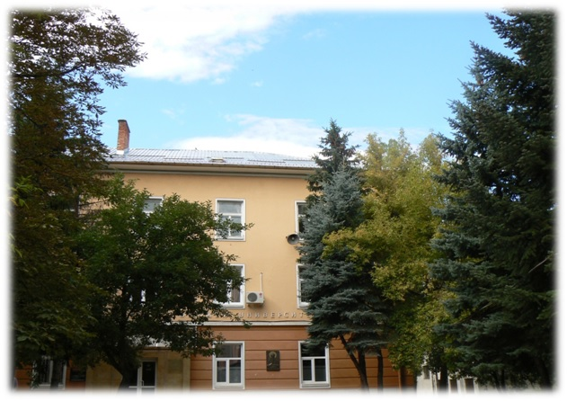

**Prof. Dr. IVAN NISHKOV**

**Head of the Central Laboratory**

**1700 SOFIA, BULGARIA · Tel. / Fax: (+359 2) 8060 253 · Tel. (+359 895) 557 114 ·**

**E-mail:** [**central.lab.mgu@gmail.com**](mailto:central.lab.mgu@gmail.com)

Provides advanced engineering, mineral processing, metallurgical testing and innovative flotation technology for the mineral processing industries.

**MODERN EQUIPPED MINERAL PROCESSING TECHNICAL LABORATORY**

* Test equipment and Trials
* Processes simulation, development and optimization

**Laboratories testing with:**

* **1.2 m leach column battery (for small leach column testing)**

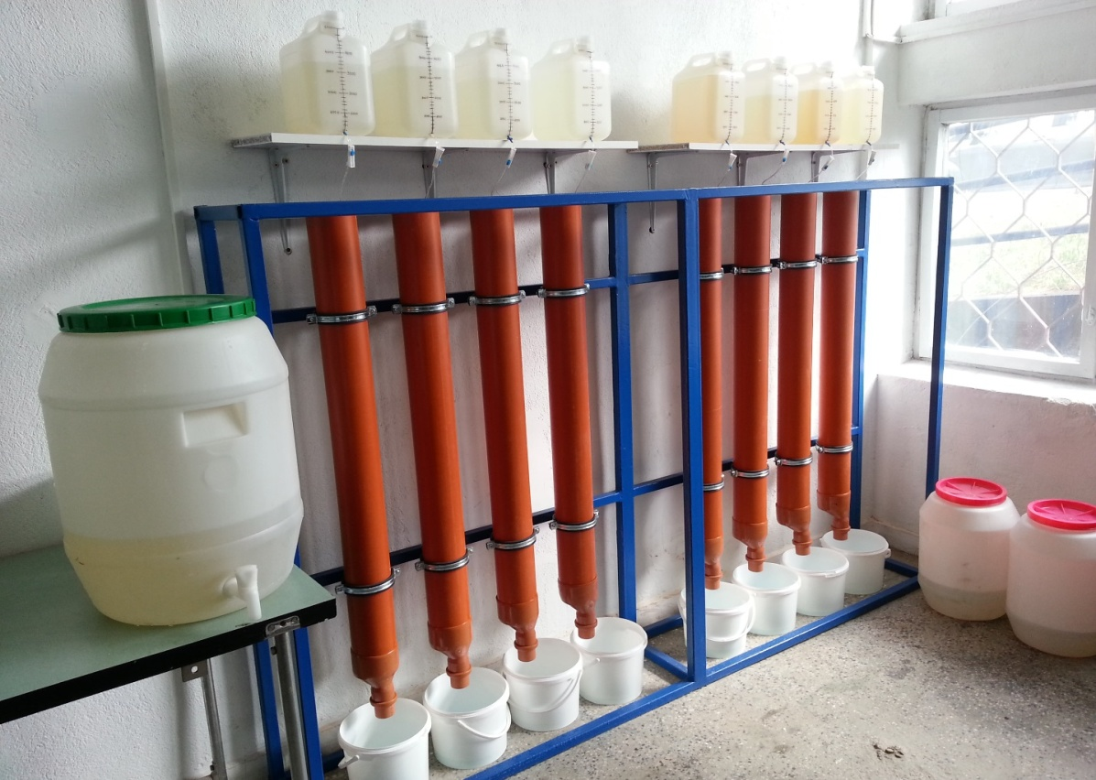

* **6 m leach columns (for tall leach column testing)**

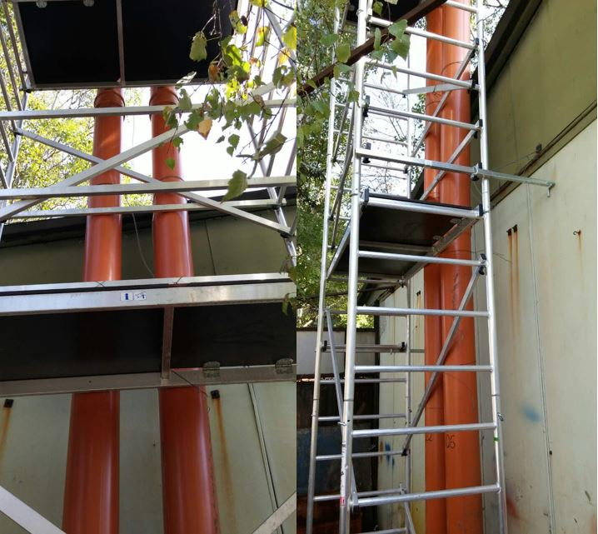

* **2-liter glass reactor (for acid consumption and agitation leach tests)**

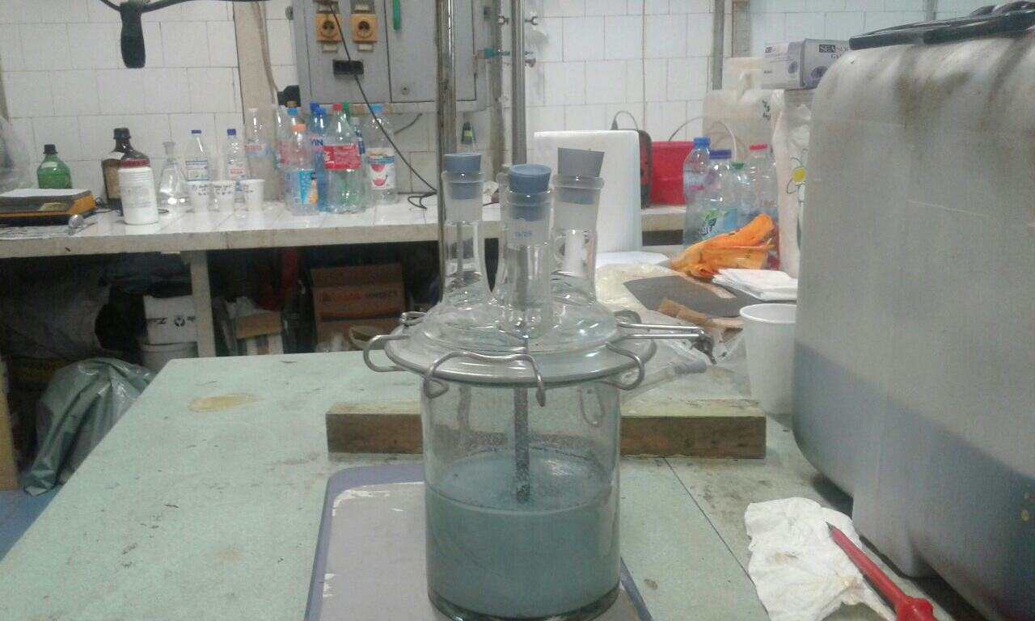

* **Solvent extraction test facility**
* **Ion exchange test column**

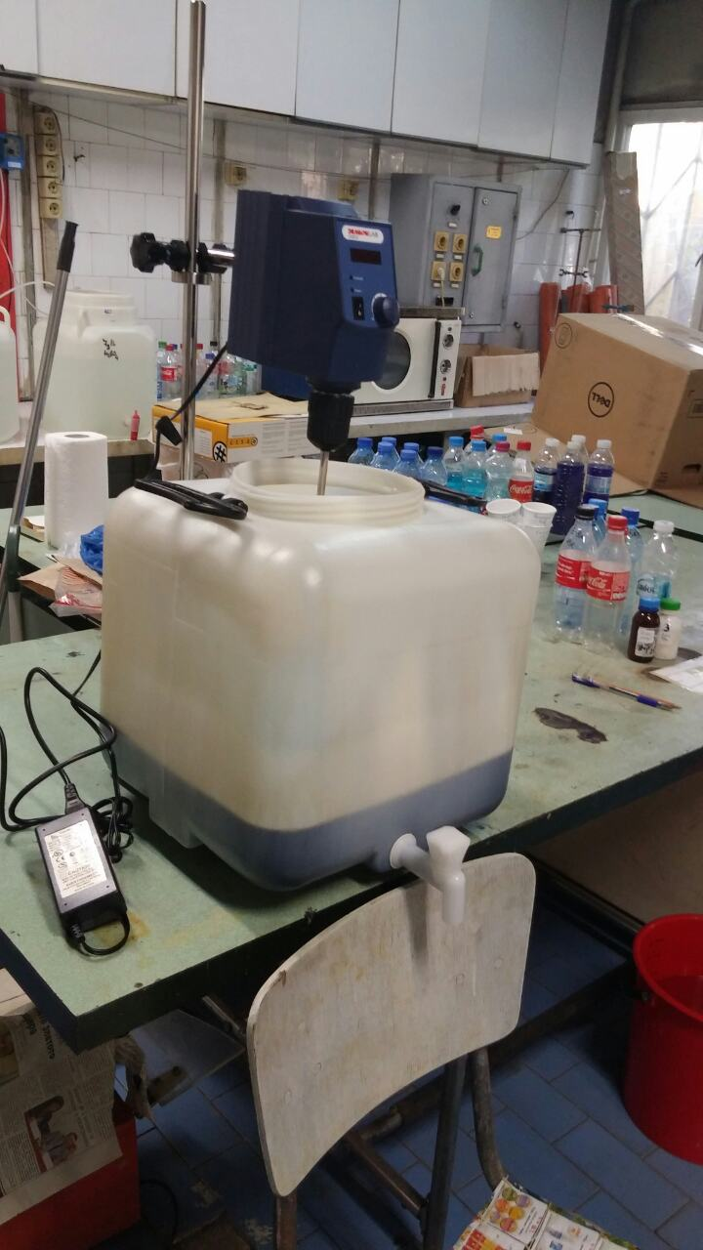 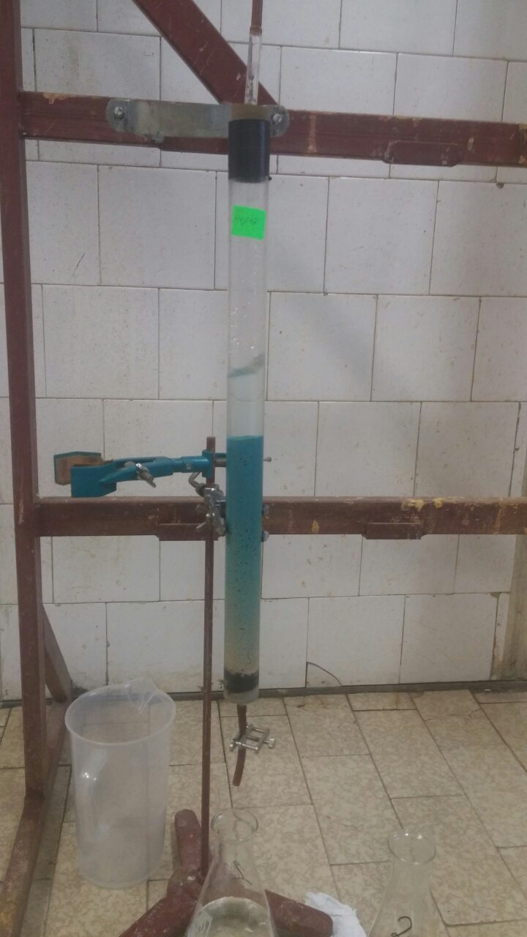

* **Bottle roll apparatus ( for bottle roll testing)**

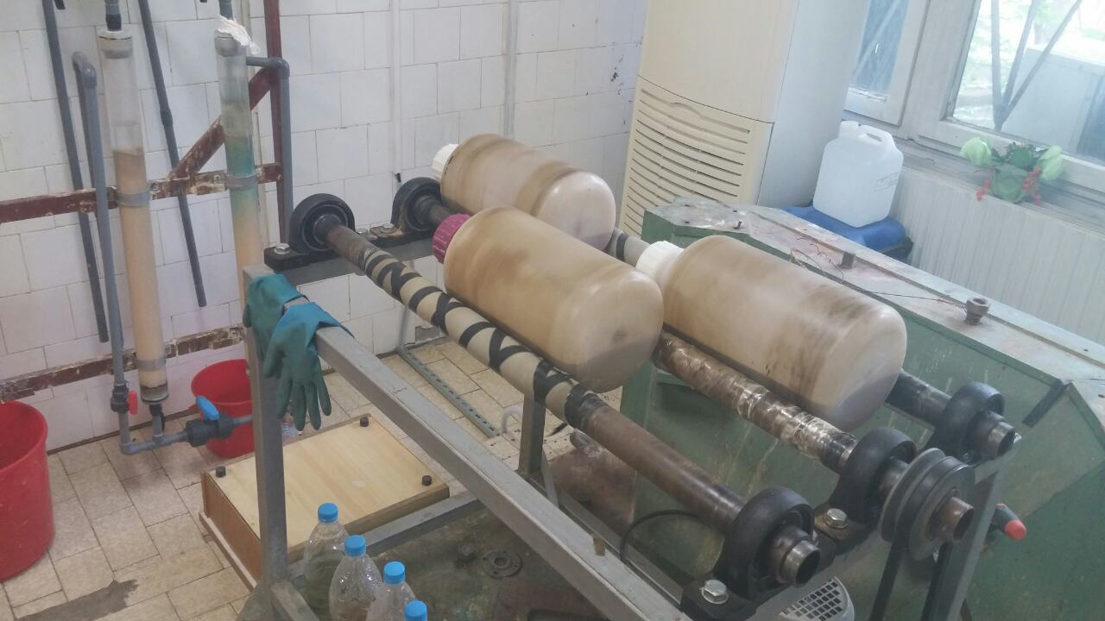

* **2-liter glass reactor (for acid consumption and agitation leach tests)**



* **Semi-continuous SFR (Staged flotation reactor) pilot plant**

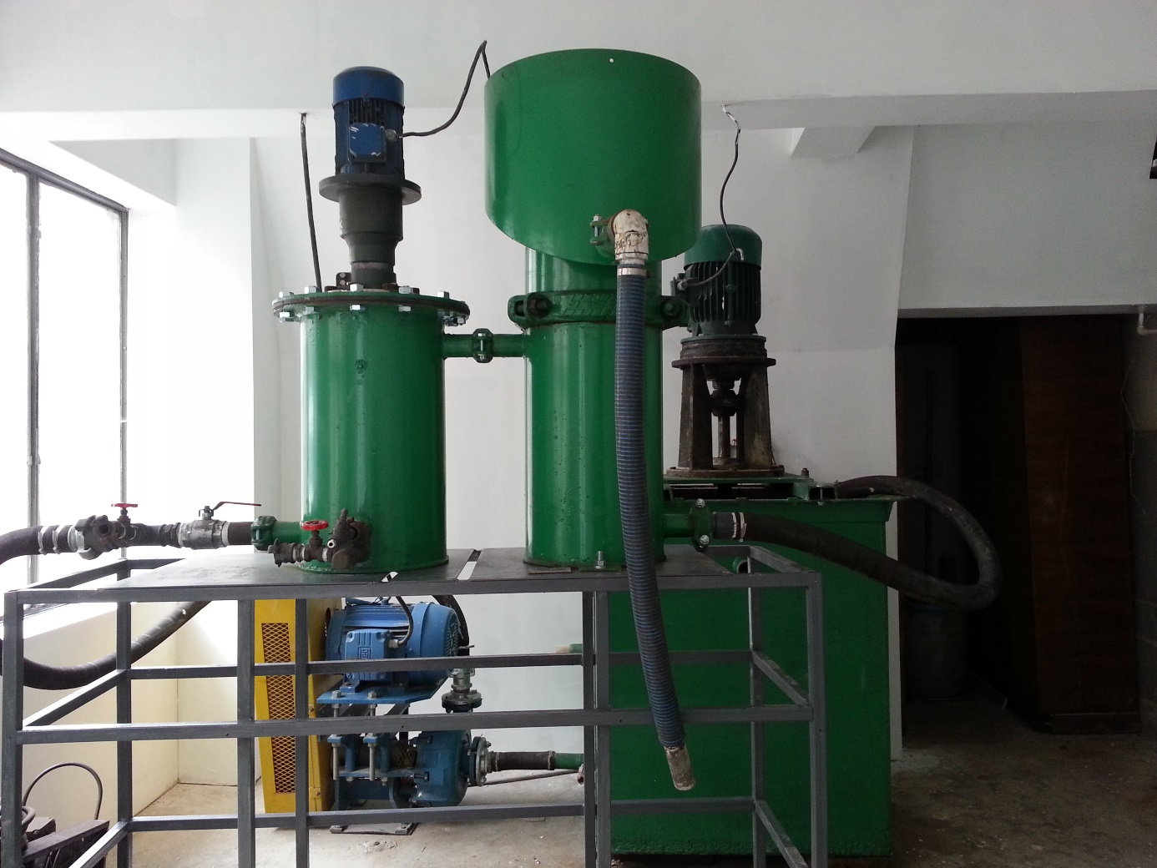

* **Ball mill**

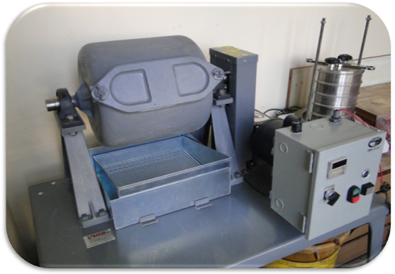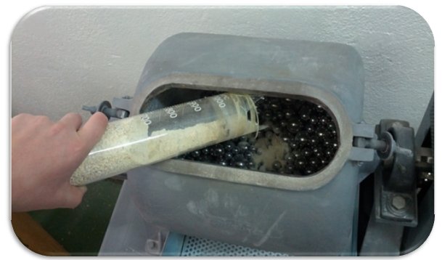

* **Laboratory KNELSON (KC-MD3) concentrator for bench-scale test work**

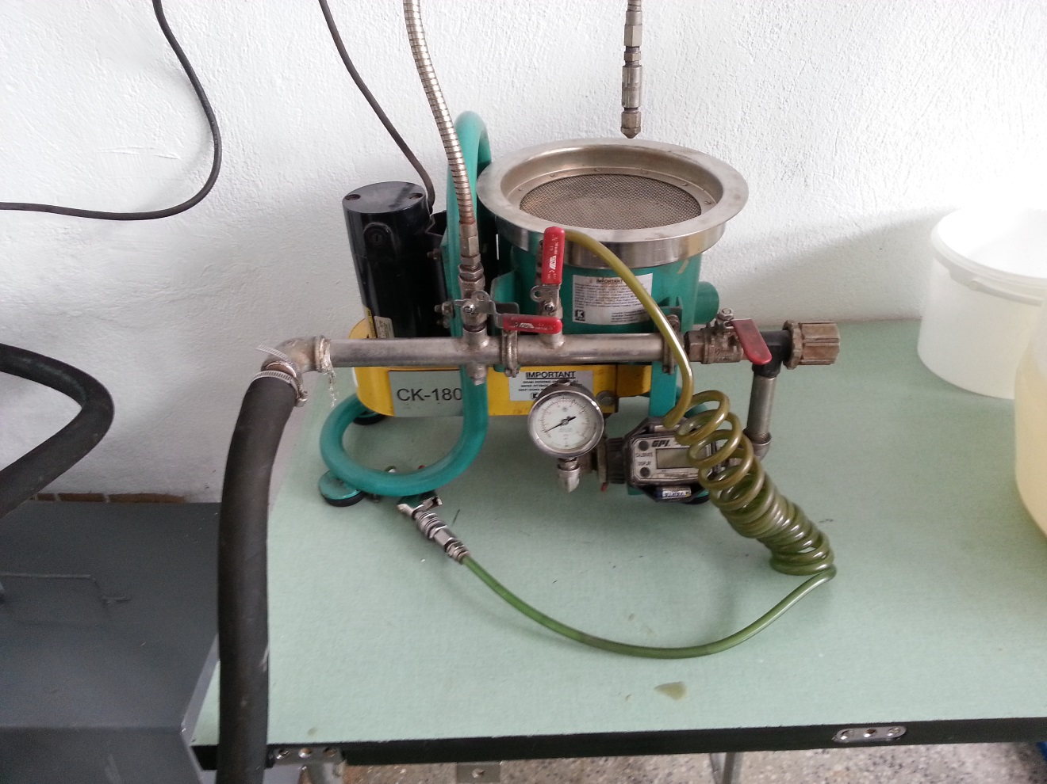

* **Zetasizer Nano ZS90**
* **Vibratory sieve shaker Analysete 3, FRITSCH**

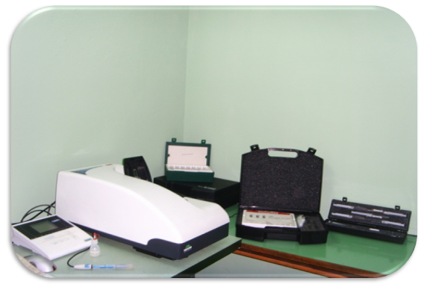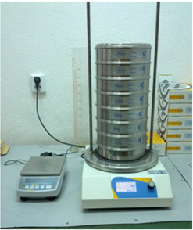

* **Laboratory flotation machines DENVER**

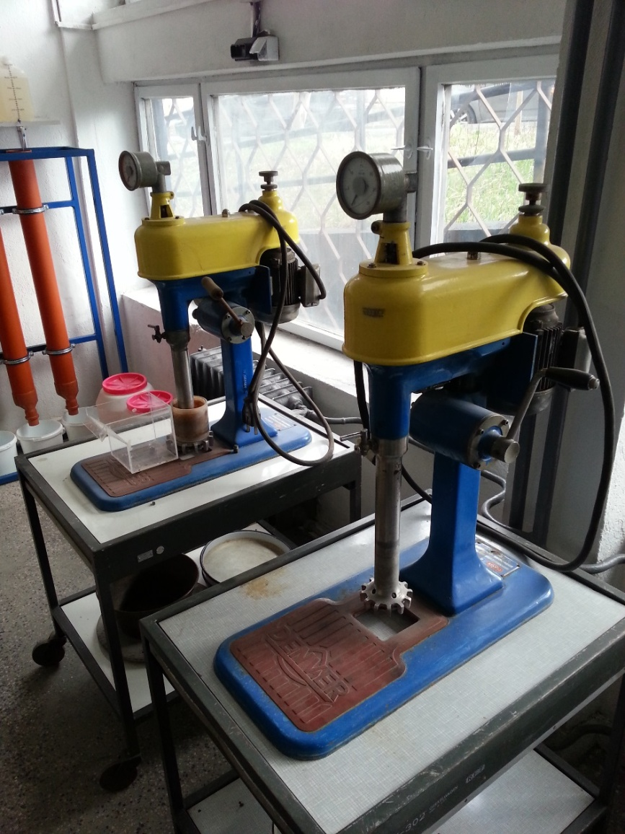

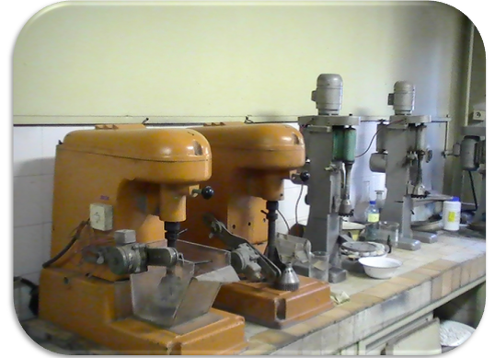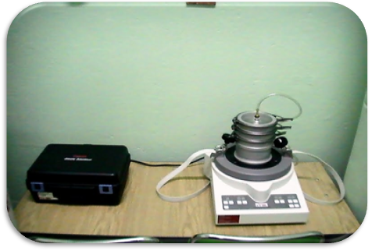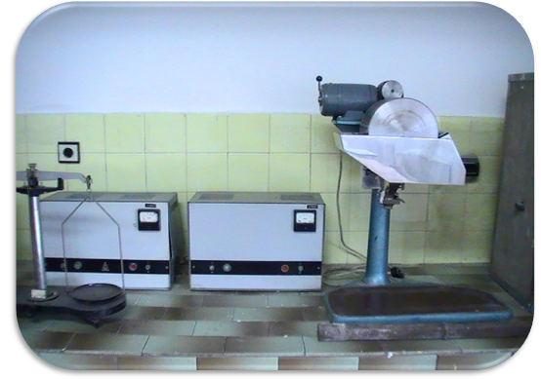

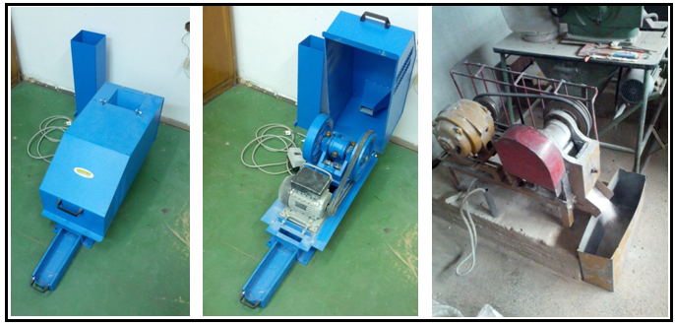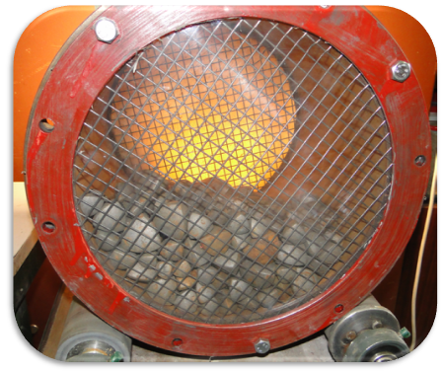

**Jaw crushers, roll mills, magnetic separators, etc.**

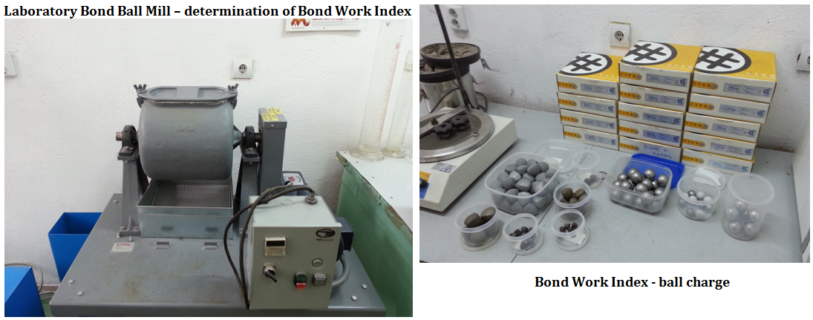

* **Rotor Beater Mill**

